Report on expert talk on “MEDICAL IMAGING TECHNOLOGY” delievered by Kalpkumar sShah, Service Manager at GE healthcare, on 8TH May, 2023

Department of biomedical engineering at government polytechnic for girls, Ahmedabad, organized an expert lecture on “MEDICAL IMAGING TECHNOLOGY” on 8th of May, 2023, from 2:00 pm to 3:00 pm at C109 classroom of biomedical engineering department. The lecture was delivered by Mr. Kalpkumar Shah, service manager at GE healthcare, Ahmedabad.
The guest speaker had delivered their lecture on current imaging technology used in the area of medical imaging. He discussed all basic imaging modalities with their technical details and also displayed the imaging equipment manufactured by GE healthcare with the basic features as well as technical specifications. The expert talk was a preface to the placement drive GE healthcare was planning to conduct at our institute premises. GE healthcare is planning to conduct an aptitude test in the next week as a first step towards their placement procedure.
The vote of thanks was given by the head of the department. BM department presented a small token of appreciation to our valuable guest. As per the feedback received from the participants it was very good learning experience, the lecture helped them in their understanding of the existing medical technologies as well as status of GE healthcare in the market of medical imaging field. Total 69 students participated in the event which included semester 6 as well as lower semester students. The event was coordinated by head of the department (incharge) Mr. Rakesh D. Motka.
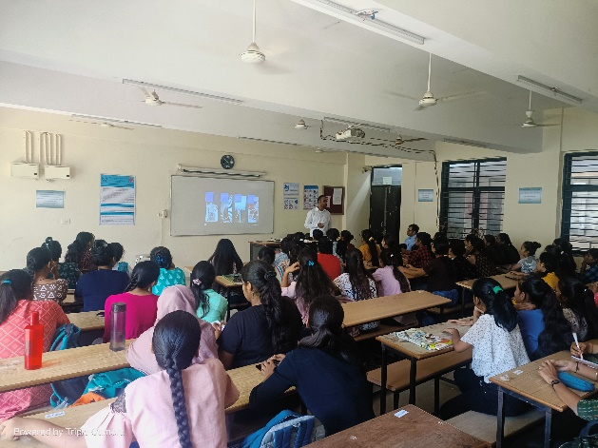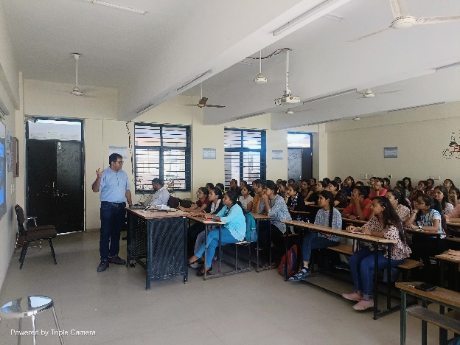

DEPT. TPO OFFICER I/C HOD

