Particulars | Details
Name of Institute | Government Polytechnic for Girls, Ahmedabad
Name of Event | Visit in Andhanj Mandal vastrapur for Physiotherapy and rehabilitation center
Types of Events | Educational visit
Start date of Event | 18/05/2024
Time | 11:00 PM onwards
Name of Event Co-coordinator | Mrs. Sharda
Nature of Participation in Event | Students only
Number of Participants in Event | 25
Facuties | 1. Meghana M Patel  2. Neelam B Modi
Venue | Andhanj Mandal vastrapur
Mode of advertisement of event | Notice Board, Students Group
Description of Events (150-word limit) | Blind People’s Association is a professional organization which believes in providing equal opportunities to all categories of people with disabilities. It promotes comprehensive rehabilitation of persons with all categories of disabilities through education, training, employment, community based rehabilitation, integrated education, research, publications, human resource development and other innovative

Learning Outcomes: .
- Identify various physiotherapy and rehabilitation services provided at the center.
- Explain the role of physiotherapy in rehabilitation for patients with different disabilities.
- Describe the types of assistive devices and therapy equipment used for rehabilitation.
- Demonstrate basic observation of therapy techniques used by professionals.
- Interact appropriately with therapists and understand patient handling with empathy and care.
- Develop empathy and sensitivity towards individuals with physical or neurological disabilities.
- Appreciate the importance of multi-disciplinary teamwork in rehabilitation.
- Reflect on the societal impact of inclusive rehabilitation services.

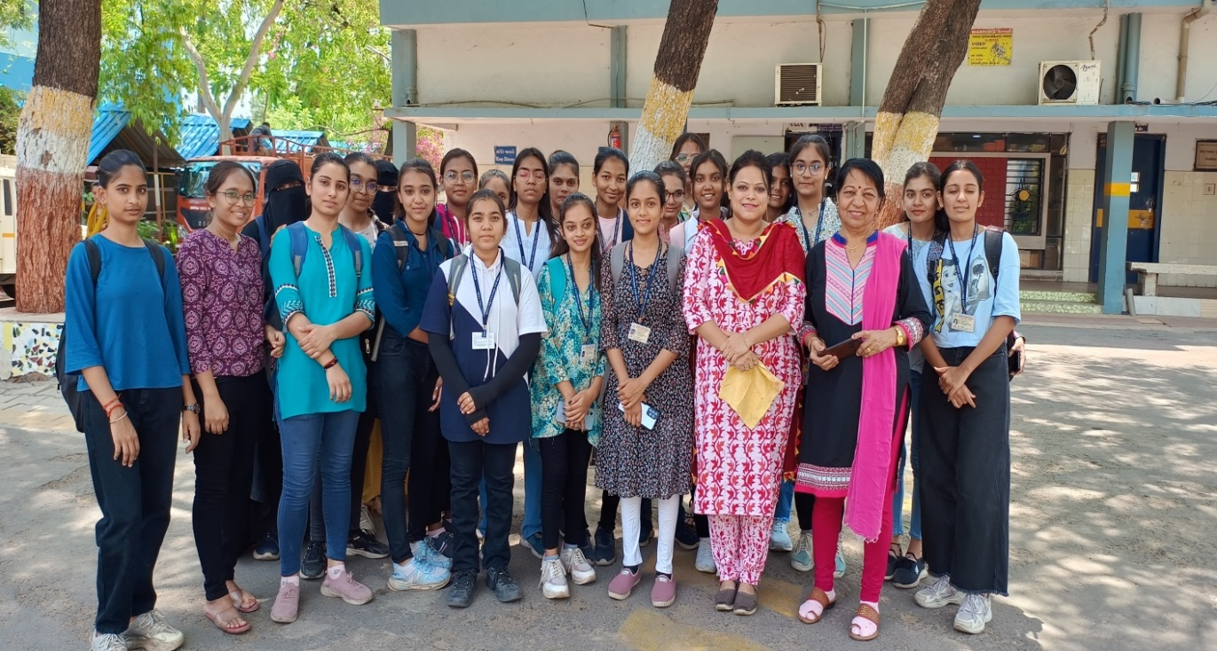
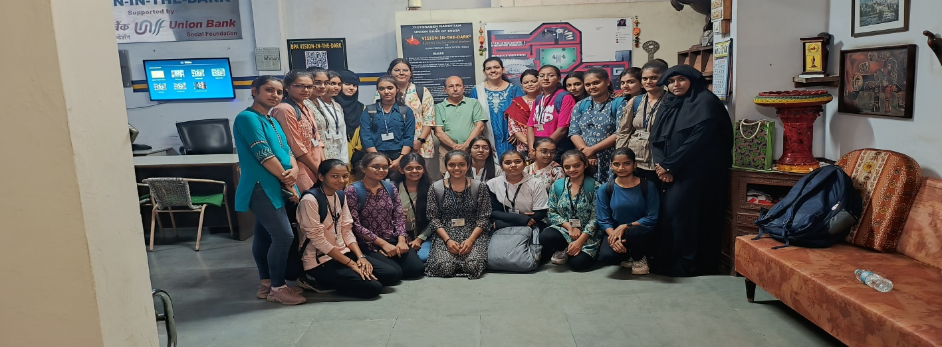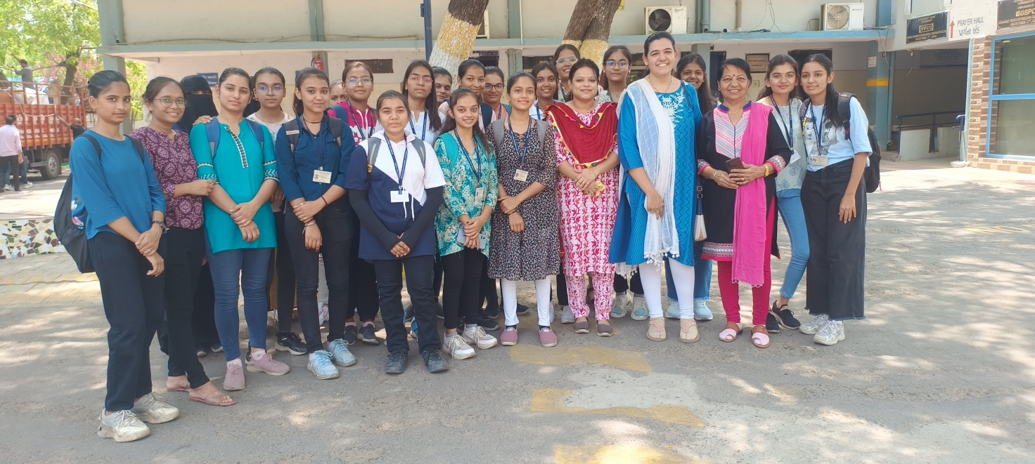 I/C Head of the department

