A report on an Expert Talk on “Pacemaker-Technical aspects and Demonstration” on 5/3/2024
The department of Biomedical Engineering organized an expert lecture on “Pacemaker- Technical aspects & demonstration” on 5th March, 2024, Wednesday. The lecture was delivered by Mr. Kushal Patel from Biosis Medical- a company that deals with sales and marketing of Medical Devices and Medical Consumables. He specifically conducted the lecture on practical aspects of pacemaker and also demonstrated the pacemaker. The speaker delivered the lecture on different types of pacemaker, different modes available in pacemaker, latest technologies in pacemakers, the method of implantation, surgical procedure for implantation, the diseases that require the need of pacemaker and the suitable pacemaker for different heart conditions etc. He came with a pacemaker kit so that the students can have the practical exposure to the device. The pacemakers are costly implants and they cannot be purchased for academic purposes. This expert talk and demonstration allowed the students to see how the pacemaker looks and what the leads of pacemaker look likes. Talk was very beneficial for second and third year students. Total 35 students of second and third year attended the event.
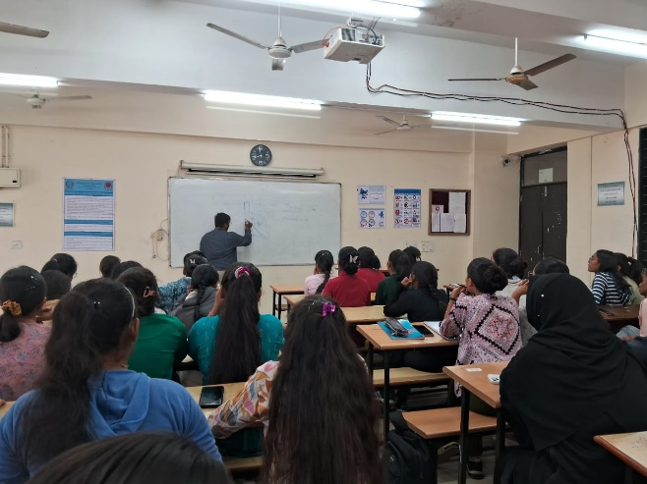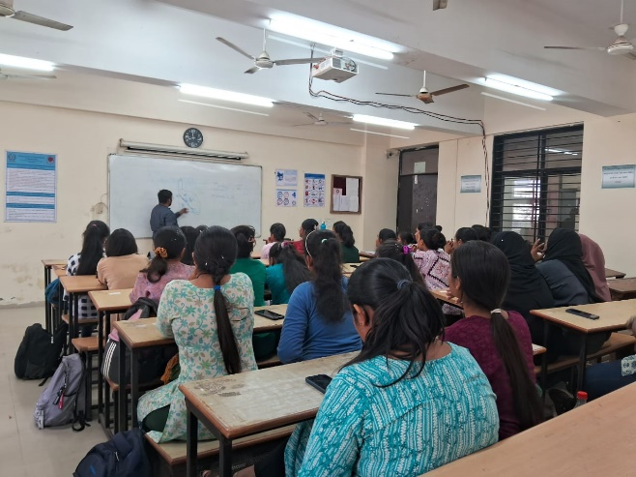
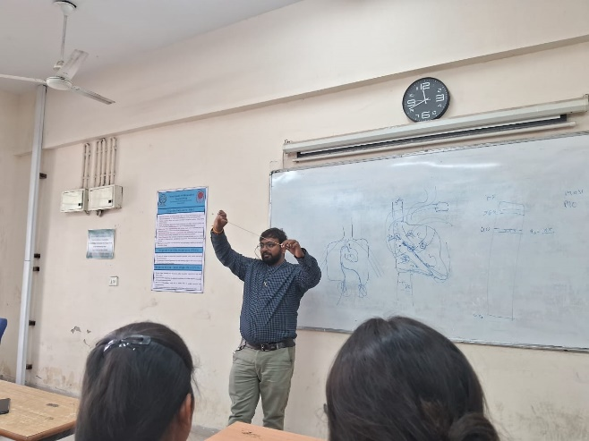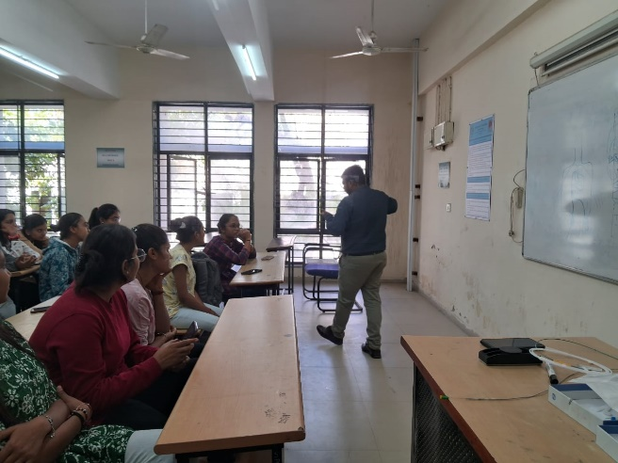

DEPT. TPO OFFICER I/C HOD

