Report on expert talk
“Introduction to biomedical Engineering and recent trends”

Particulars | Details
Name of Institute | Government Polytechnic for Girls, Ahmedabad
Name of Event | “Introduction to biomedical Engineering and recent trends”
Types of Events | Expert Talk
Start date of Event | 29/11/2024
Time | 11:00 PM onwards
Name of Expert | Ms. Pooja L. Gohel
Nature of Participation in Event | Students only
Number of Participants in Event | 30
Venue | New Building Room no. 106
Mode of advertisement of event | Notice Board, Students Group
Faculty Coordinator | - Ms. Meghana M Patel  - Ms. Neelam B Modi
Description of Events (150-word limit) | Expert talk “Introduction to biomedical Engineering and recent trends”  The intent of the expert talk was to provide exposure to the recent trends in Biomedical Engineering which will expand students minds to understand innovative technologies in the healthcare system and the content was a good addition to the knowledge in the subject Fundamentals of Biomedical Engineering.  The session was an eye-opening session for the first year students as it focused on Application of engineering principles design concepts to medicine and biology. It seeks to close the gap between engineering and medicine by designing products and procedures that solve medical problems  This session was intended to orient students to understand and develop interest about What does a Biomedical Engineer do, Fields of Biomedical Engineering, Skills a biomedical engineer should have.  The students gain the knowledge on  - Introduction to Biomedical Engineering  - Measurements and Instrumentation in Healthcare  - Bioelectric Signals and Transducers  - Applications and Future Trends  - Recent advances in Biomedical Instrumentation and Techniques  Students felt that all the topics were very much informative. The students were introduced to recent trends in biomedical engineering. This will in turn help them to think, design, understand and develop innovative technologies in the biomedical field.

Learning Outcomes:
- To understand the crucial role of biomedical engineers to develop new medical technologies, and in improving the quality of healthcare for people around the world.
- The students will understand the recent innovative technologies in the biomedical engineering field.

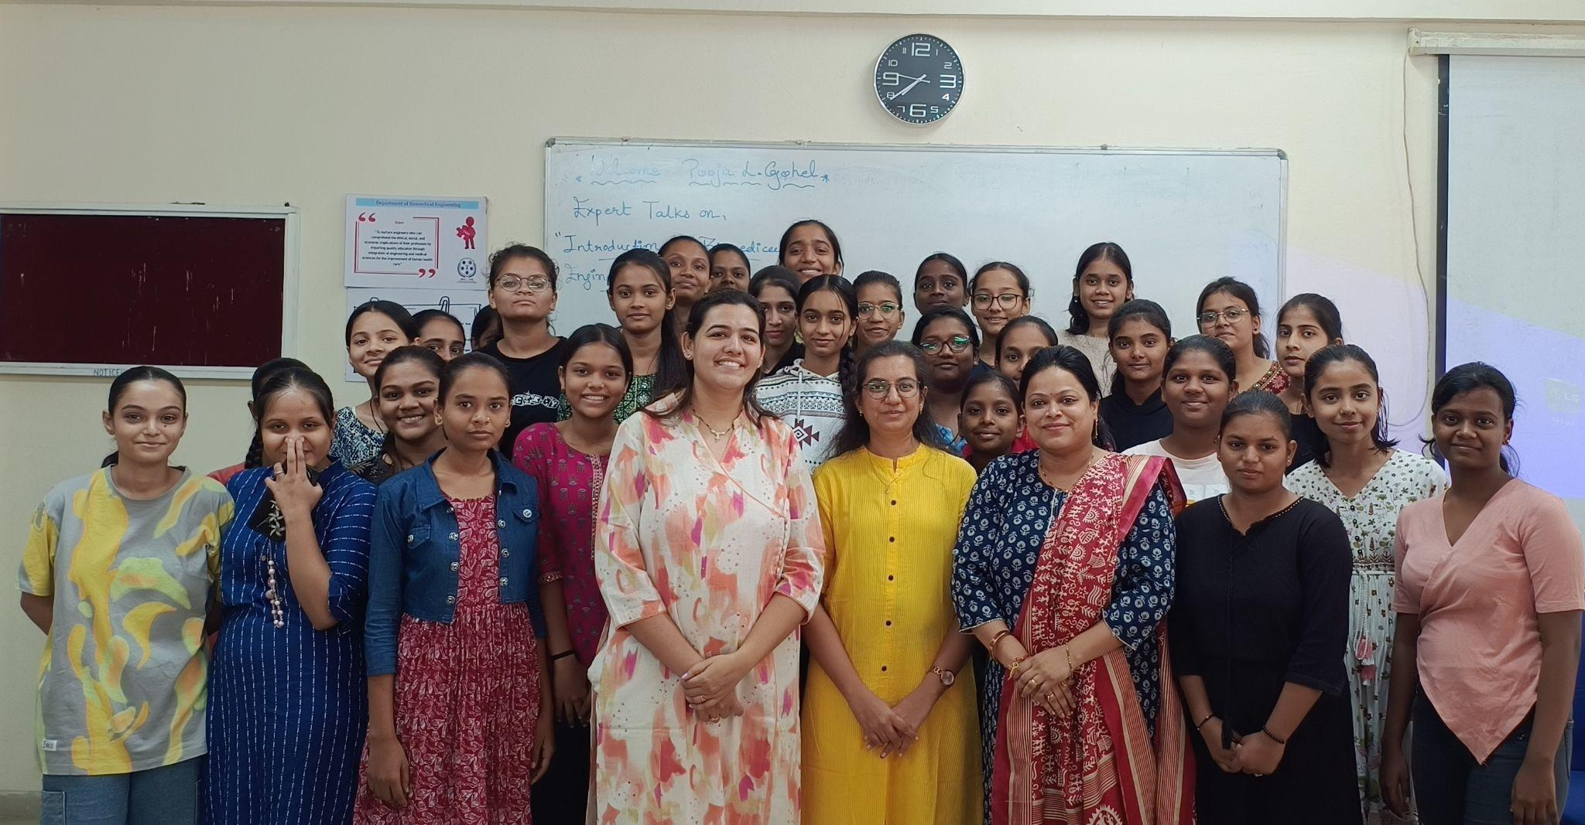
In the middle with yellow attire is Ms.Pooja Gohel
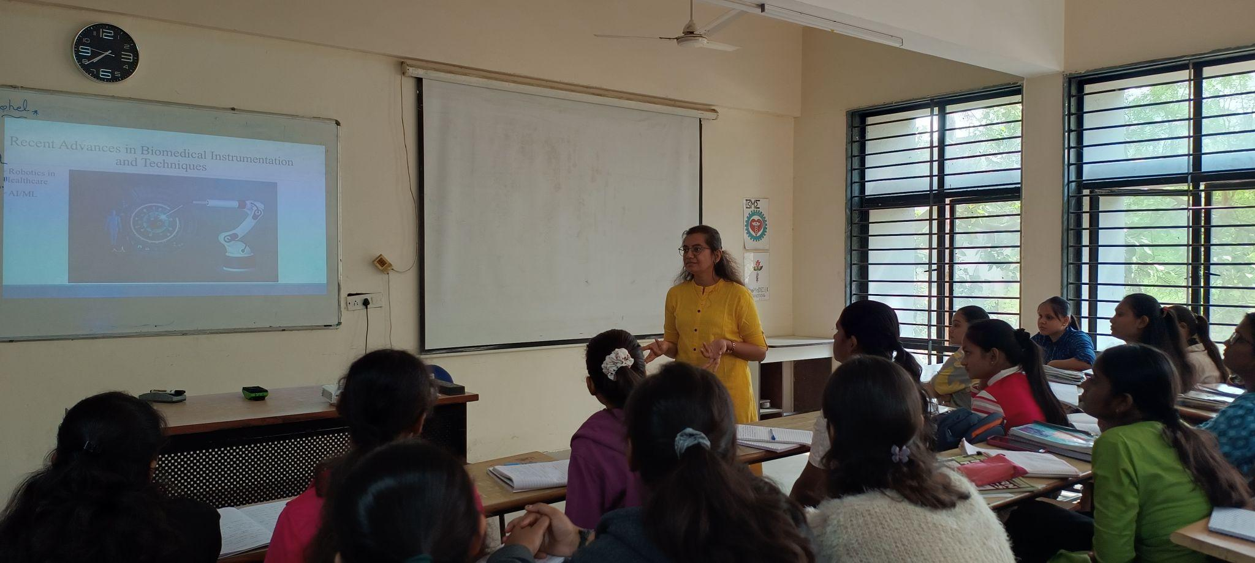
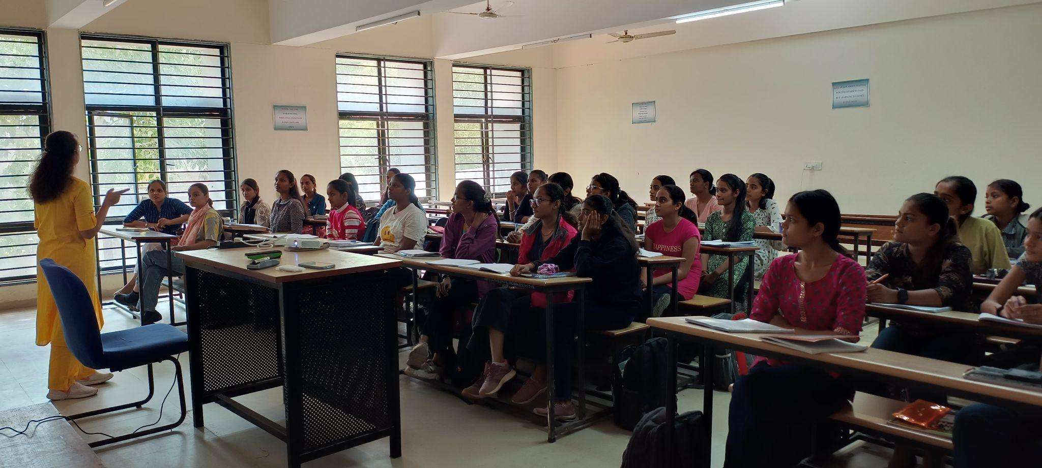
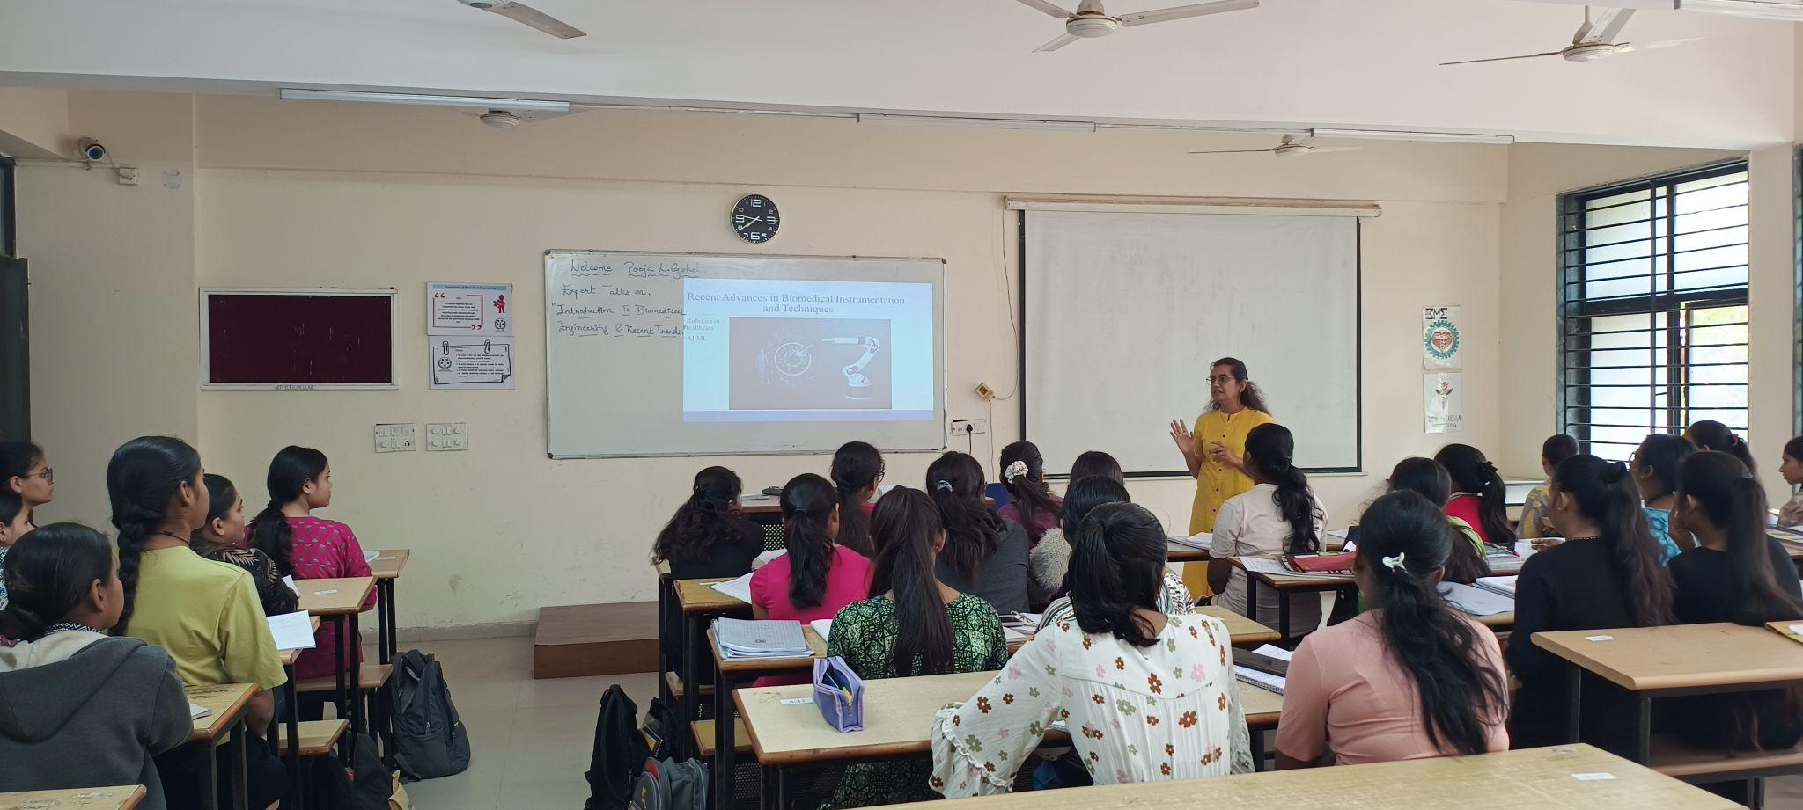

TPO Coordinator Head of the Department

