Particulars | Details
Name of Institute | Government Polytechnic for Girls, Ahmedabad
Name of Event | Start-up story-Motivational session by shubham shah
Types of Events | Motivational Talk
Start date of Event | 05/09/2024
Time | 11:00 PM onwards
Name of Expert | Mr. Shubham Shah
Nature of Participation in Event | Students only
Number of Participants in Event | 30
Venue | New building room no 102
Mode of advertisement of event | Notice Board, Students Group
Description of Events (150-word limit) | Startup story - Motivational Session by Subham Shah the esteemed journey of Edith Healthcare.  The intent of the session was to provide an opportunity to aspiring young entrepreneurs to listen to him who have already taken the entrepreneurial route successfully.  The session was an eye-opening session for the budding young minds, and it aimed to impart the skills needed to handle the different tools and technologies that are useful in real time scenarios. This session was intended to orient participants towards starting their own enterprise, with focus on the decisions that an entrepreneur takes and sources of finance  The students gain the knowledge and motivation on  • Life journey of an innovator  • Idea generation and start-up  • Interpersonal skills in entrepreneur  • Practical Entrepreneurial skills and knowledge  Students felt that all the topics where very much informative. The students got many technical inputs and motivation regarding start-ups. This will in turn help them to start the ideation on socio-economic products.

Learning Outcomes: The students will understand the journey of being an entrepreneur or establishing a start up on self.
The difficulties & challenges they will encounter during the process and how to handle such types of situations.

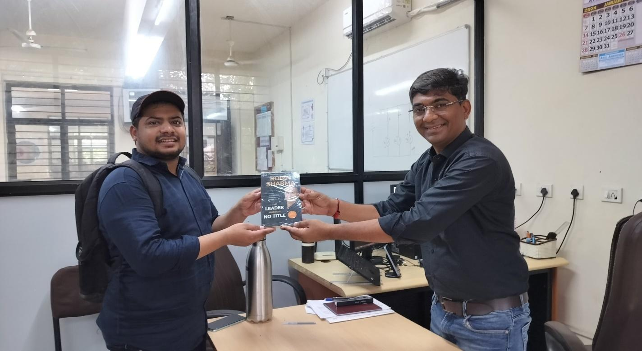
Mr. Rakesh D motka offering memento to Mr Shubham Shah as a gratitude from BM Department

