Particulars | Details
Name of Institute | Government Polytechnic for Girls, Ahmedabad
Name of Event | Industrial visit at
Types of Events | Academic visit
Start date of Event | 11/03/2025
Time | 12:30 PM onwards
Name of Industry Representative | Ms. Shweta Panchal
Faculty | Mr. Rakesh D. Motka  Ms. Jimisha H. Suthar
Nature of Participation in Event | Students only
Number of Participants in Event | 22
Venue | Proactive Healthcare Inc., Santej, Ahmedabad
Mode of advertisement of event | Notice Board, Students’ Whatsapp Group
Description of Events | Established in 2007, Proactive Health Inc. (PHI) has evolved into a comprehensive medical device manufacturing company. Initially focusing on the supply of medical devices. PHI offers a diverse range of medical and healthcare devices, including:​  - Blood Glucose Meters  - Blood Pressure Monitors  - Nebulizer Machines  - Infrared Thermometers  - Breastfeeding Pumps  - Doppler Fetal Monitors  - Oxygen Concentrators  - Medical Stethoscopes  - Body Weight Machines​  These products are recognized for their durability and technical soundness, offered at competitive prices. During the visit, students had the opportunity to witness the end-to-end manufacturing process of various medical devices such as glucometers, blood pressure monitors, and nebulizers. They observed the use of injection molding machines for plastic components, cleanroom environments for assembly, and rigorous quality testing procedures. The students also interacted with engineers who explained the importance of precision, safety standards, and regulatory compliance in the healthcare industry.

Learning Outcomes:
- Understanding of Medical Device Manufacturing: Students gained firsthand knowledge of how biomedical devices are designed, assembled, and tested in an industrial setup.
- Exposure to Industrial Processes: Students observed processes such as plastic injection molding, PCB integration, and final product testing, enhancing their understanding of industrial workflows.
- Linking Theory to Practice: The visit helped students bridge the gap between theoretical concepts taught in class and their practical applications in real-life healthcare solutions.

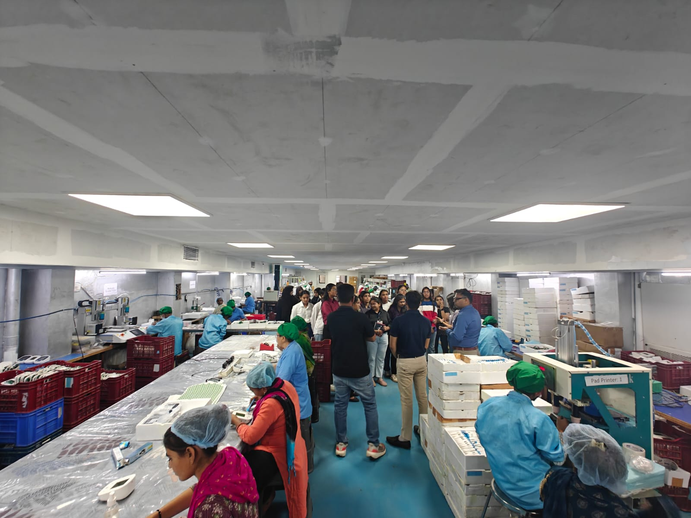
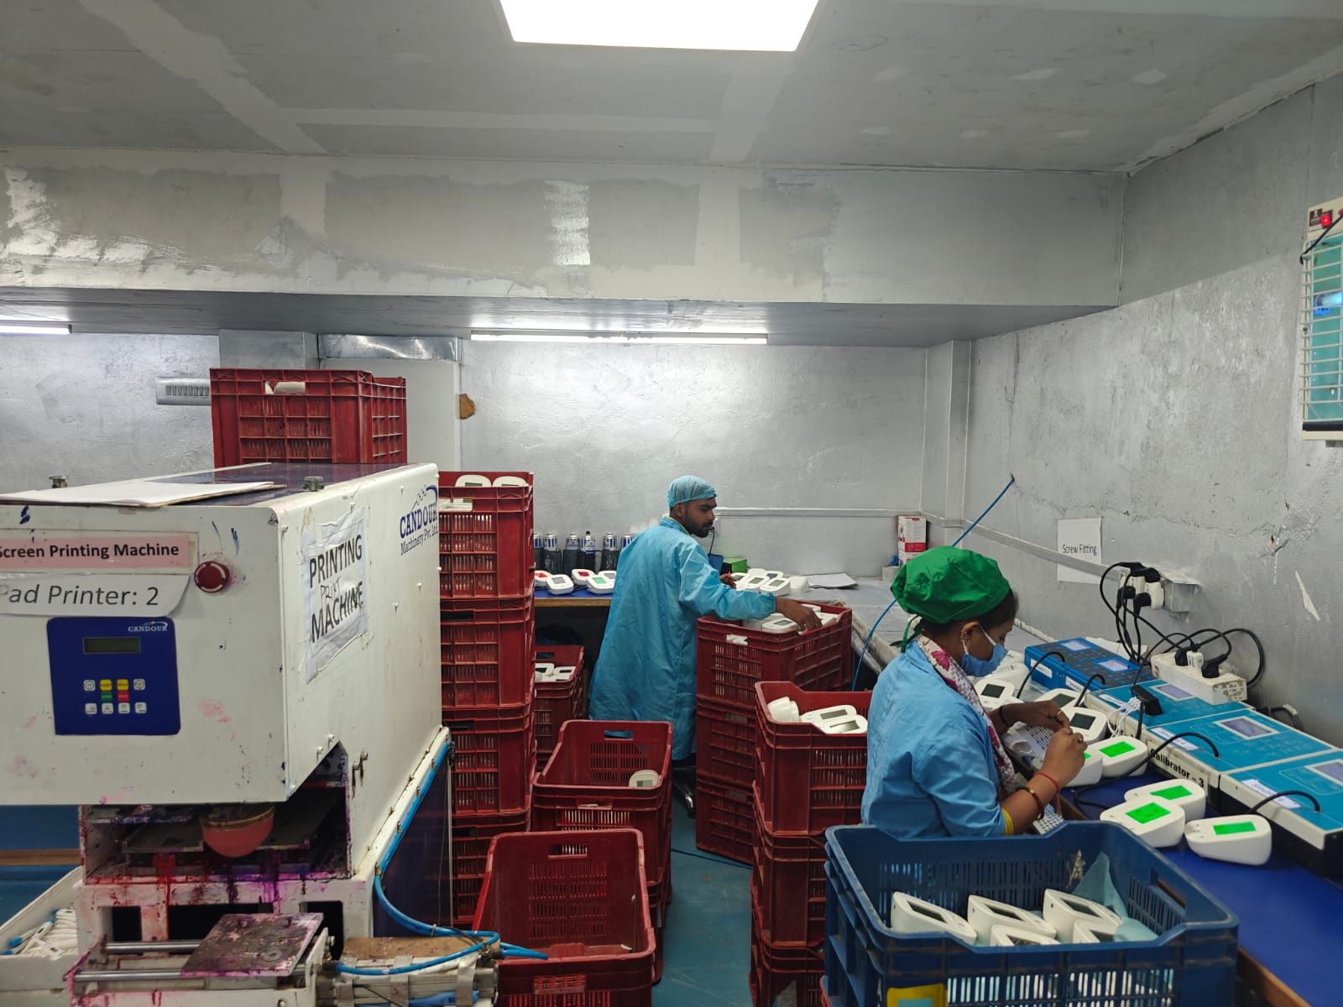
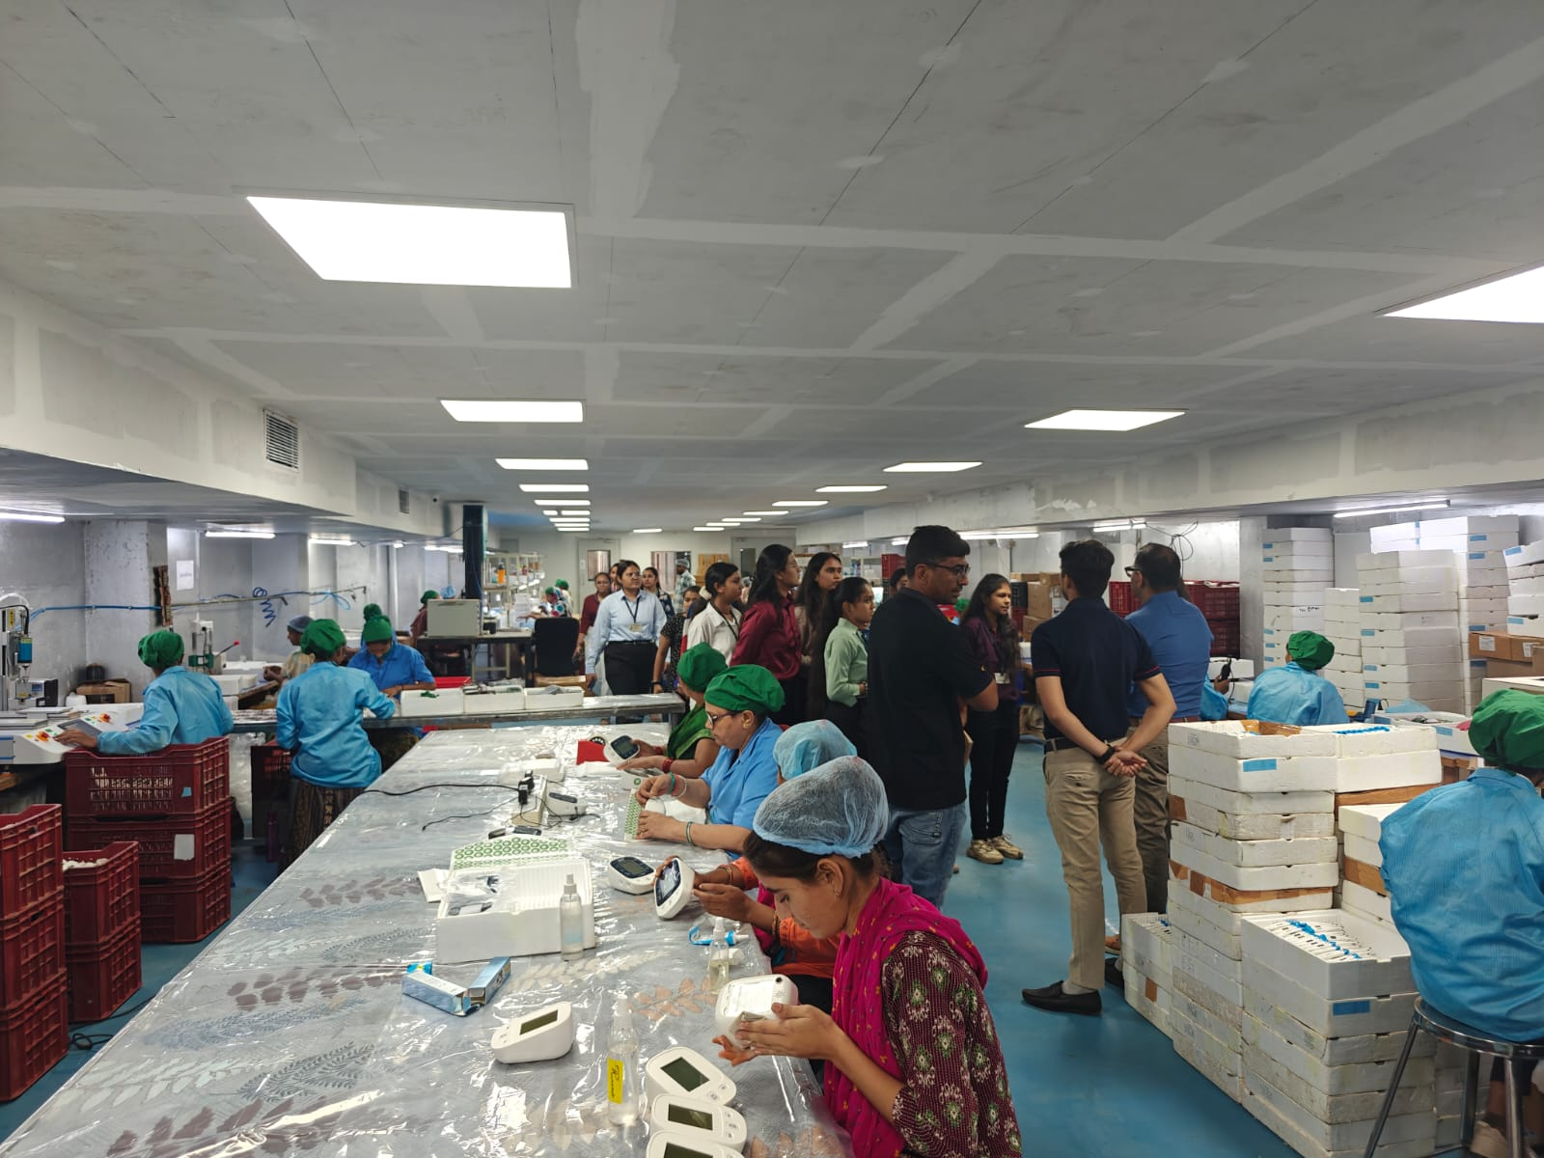
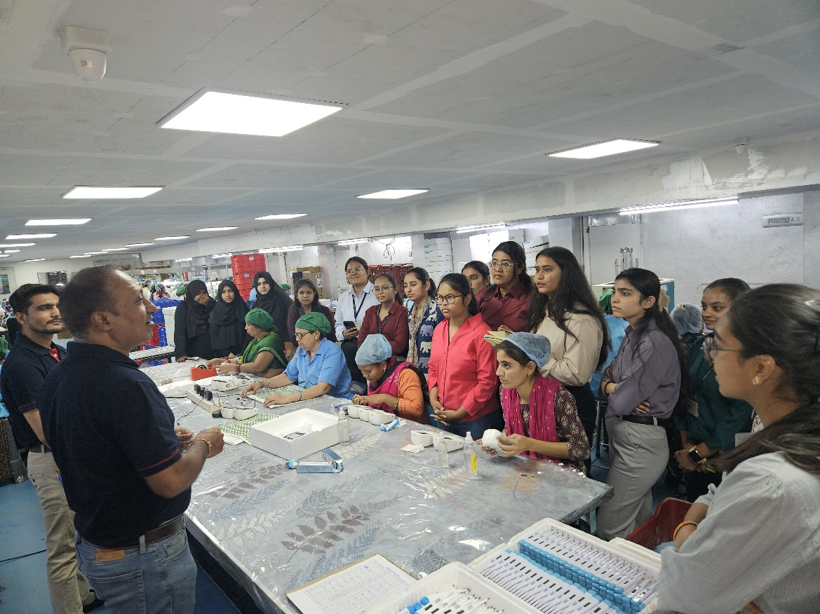
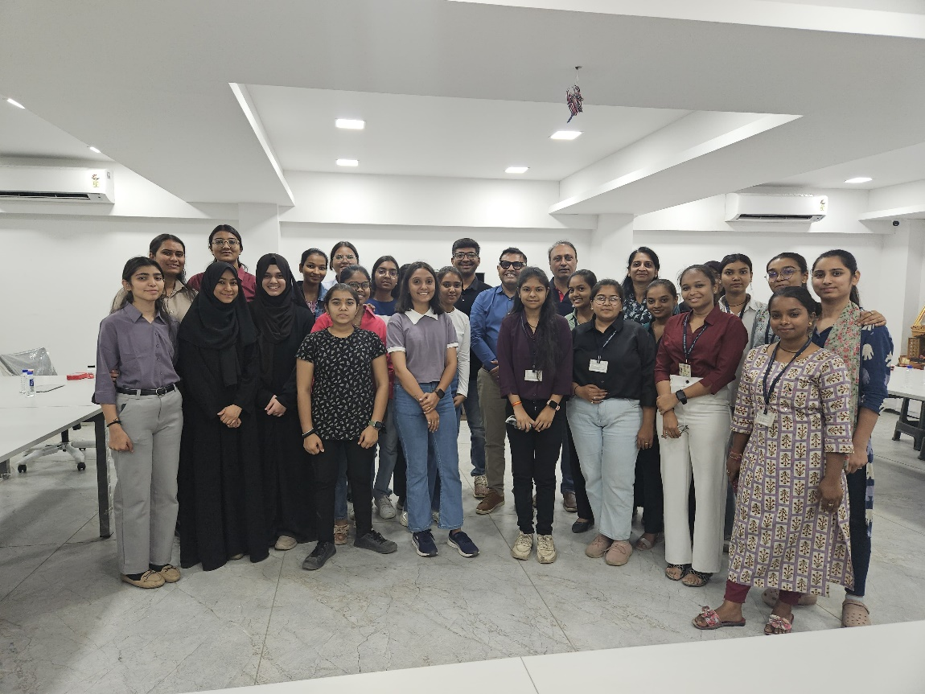

TPO Coordinator Head of the Department

