Particulars | Details
Name of Institute | Government Polytechnic for Girls, Ahmedabad
Name of Event | Hospital Visit “One day visit Trisha Multispecialty Hospital Ahmedabad”
Types of Events | Hospital Visit
Start date of Event | 13/03/2025
Time | 12:30 PM onwards
Name of Hospital Representative | Ms. Mamta Nayi
Faculty | Ms. Meghana M Patel  Ms. Neelam B Modi
Nature of Participation in Event | Students only
Number of Participants in Event | 32
Venue | Trisha Multispecialty Hospital Ahmedabad
Mode of advertisement of event | Notice Board, Students Group
Description of Events | Hospital visit provided students with the opportunity to experience under the guidance of experienced professionals.  Students could apply their theoretical knowledge to real-life scenarios, helping them understand how concepts translate into practice.  The students gain the knowledge on:  - Pathological Instruments- analytical instruments include microscopes, hematology analyzers, biochemistry analyzers, coagulation analyzers, and instruments for techniques like ELISA, PCR, used for various sample analyses and disease diagnosis.  - Physiotherapy instruments - instruments commonly include electrotherapy devices like TENS units and ultrasound machines, Short wave diathermy machine and Lasers used for musculoskeletal issues, along with various accessories for pain management and rehabilitation  - Diagnostic instruments: like multi-Para monitor and ECG Machine for diagnosis.  - Hemodialysis machine and oxygen generation plant  Overall it was a fruitful experience for students exploring various instruments and its applications

Learning Outcomes:
- Practical Knowledge and Skills: Students gain firsthand experience of hospital operations, processes, and technologies, complementing their theoretical knowledge.
- Visits can help students understand different industries, roles, and career paths, aiding in making informed career decisions.
- Seeing concepts in action makes learning more engaging and memorable, boosting academic performance and motivation.
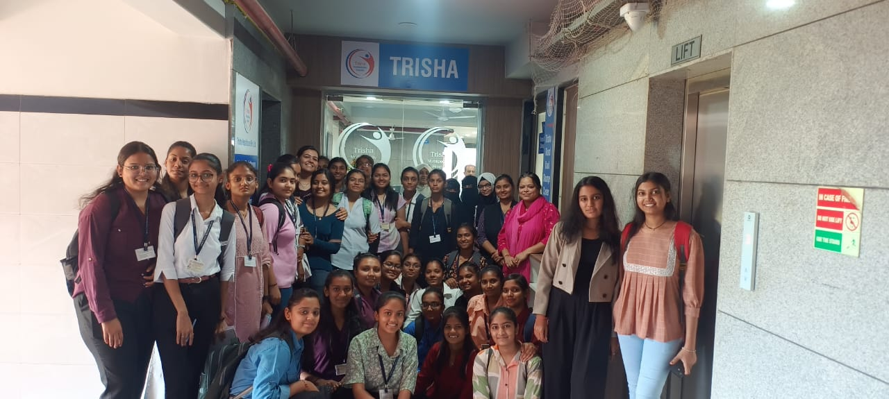
Group Picture at Trisha Multispecialty Hospital
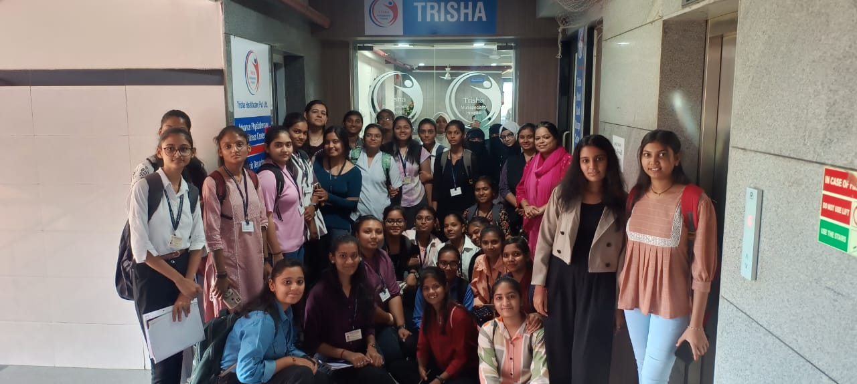
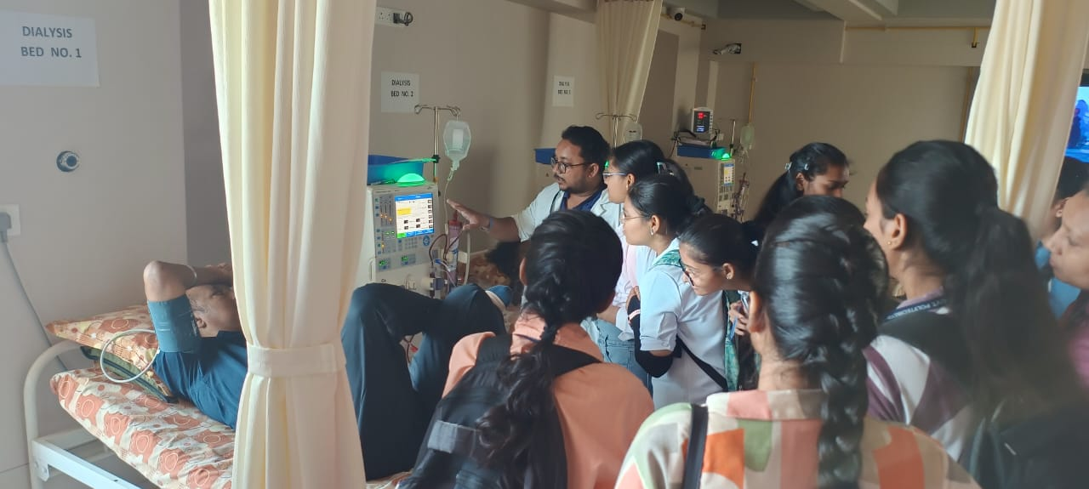
Hemodialysis Machine
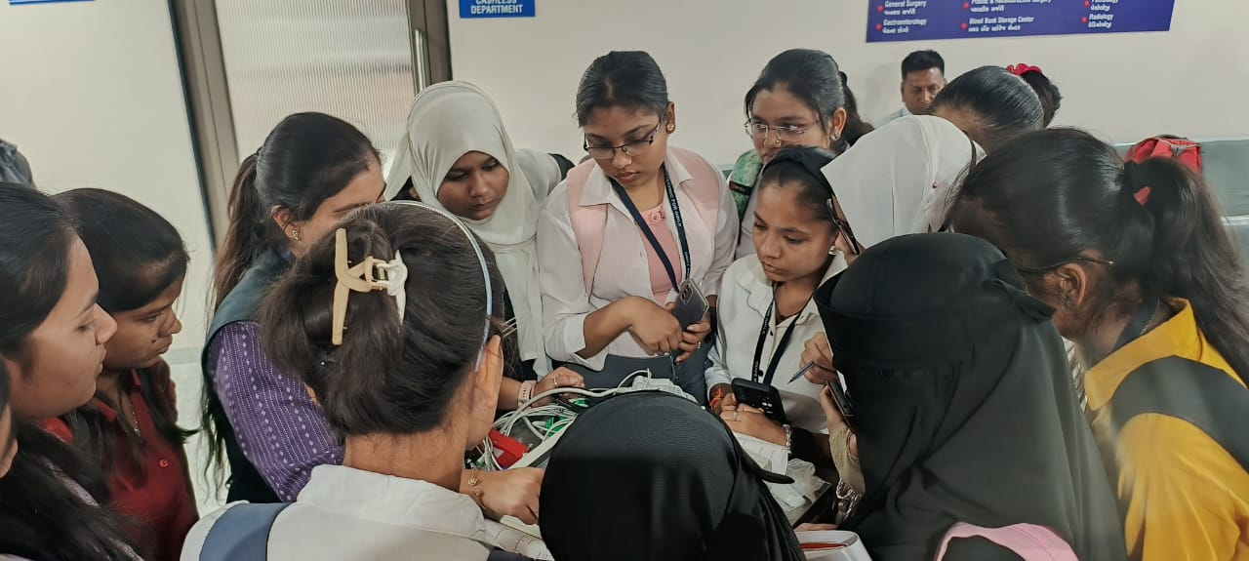
ECG Machine

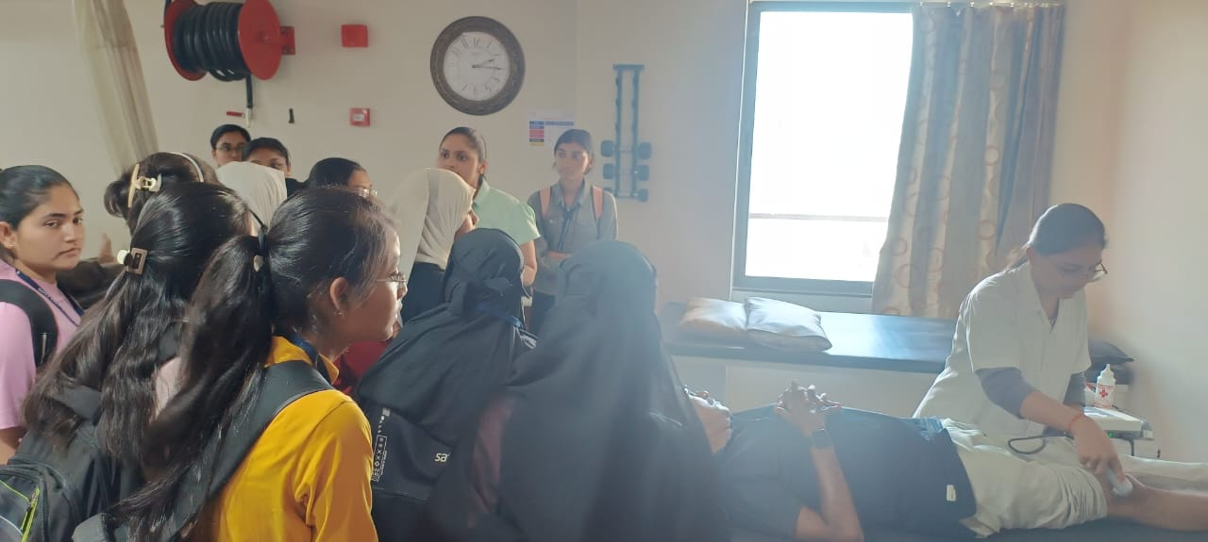
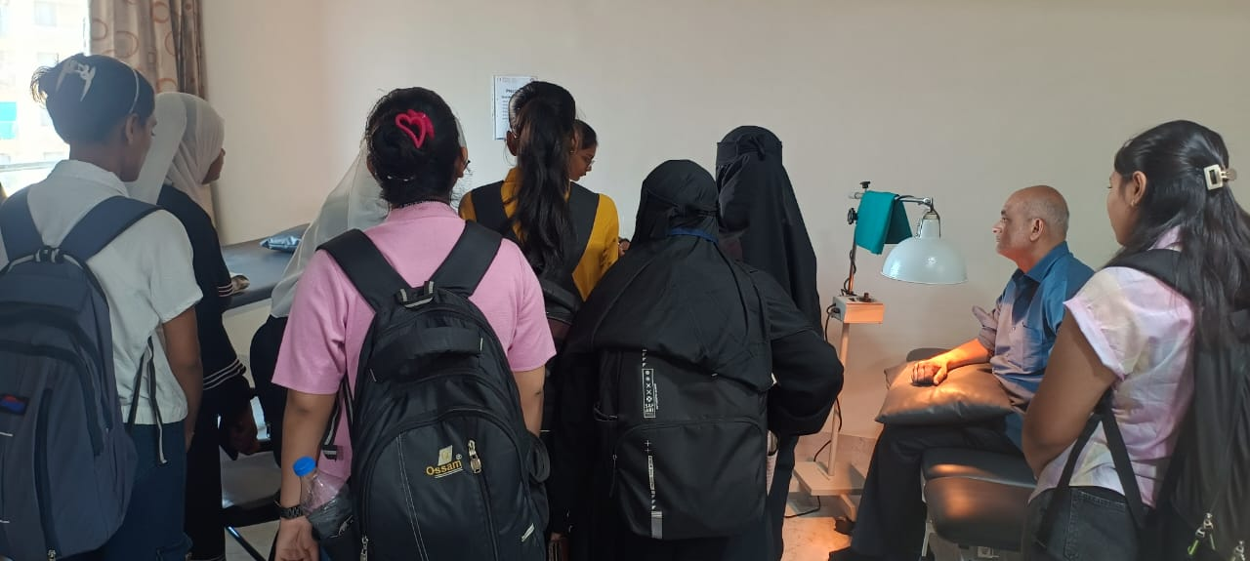
Physiotherapy Center
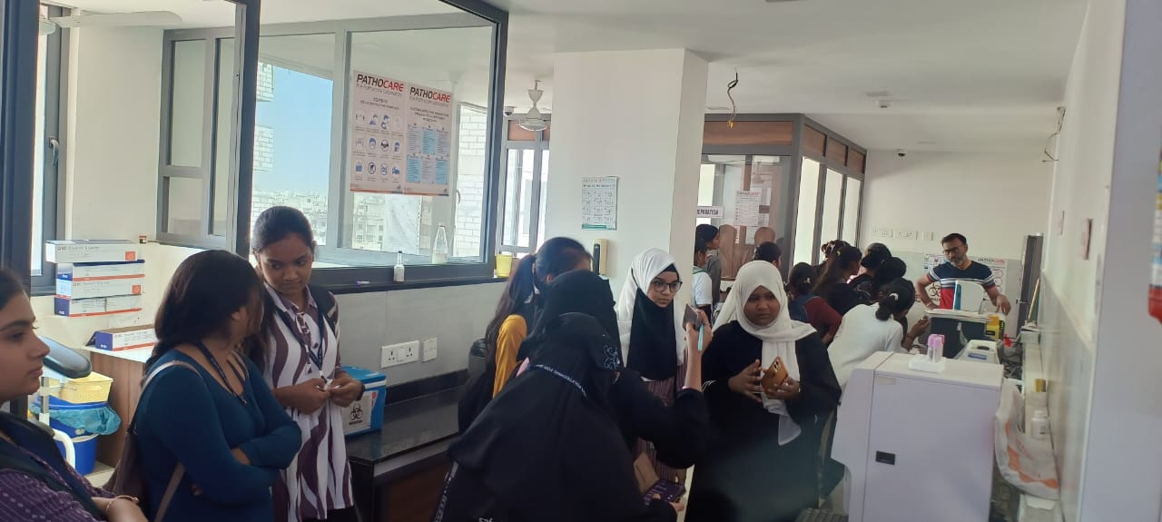
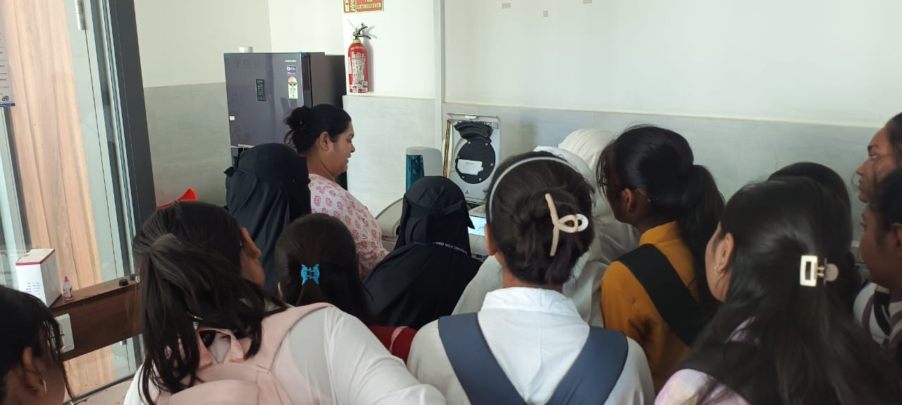

Pathology Laboratory

TPO Coordinator Head of the Department

