Particulars | Details
Name of Institute | Government Polytechnic for Girls, Ahmedabad
Name of Event | Expert talk on “3D Printing and its application”
Types of Events | Expert Talk
Start date of Event | 18/02/2025
Time | 11:30 PM onwards
Name of Expert | Mr. Chirag Vyas from Lak techne India private limited
Faculty Coordinator | Ms. Meghana M Patel  Mr. Rakesh D Motka
Nature of Participation in Event | Students only
Number of Participants in Event | 95
Venue | New building room no 106
Mode of advertisement of event | Notice Board, Students Group
Description of Events | Expert talk by Chirag Vyas - 3D Surgical | Segmentation, Preoperative surgery Planning, Patient Specific Implants, 3D Model, R & D / #CSR Consultant / Business Development from “Lak techne India private limited”.  The intent of the session was to provide the information about development and delivery of patient-specific, advanced, and customized 3D healthcare products and services, such as surgical guides, anatomy  Model segmentation and metal implants.  The students gain the knowledge on:  - Surgical planning -3D printing and surgical planning software can help doctors create customized models of a patient's anatomy.  - Bioprinting-3D bio printing is a process that uses living cells and biomaterials to create tissues and organs.  - Anatomical models 3D printed anatomical models can be used to improve patient education and communication.  Students felt that all the topics covered were very much informative. The students got many technical inputs and motivation regarding 3d printing as the upcoming technology.

Learning Outcomes:
- To understand the basics of 3D printing and its applications.
- Operate the hardware of 3D printer
- The students will understand the significance of 3D printed models which provide opportunity for increased comprehension of anatomical and pathological structures.

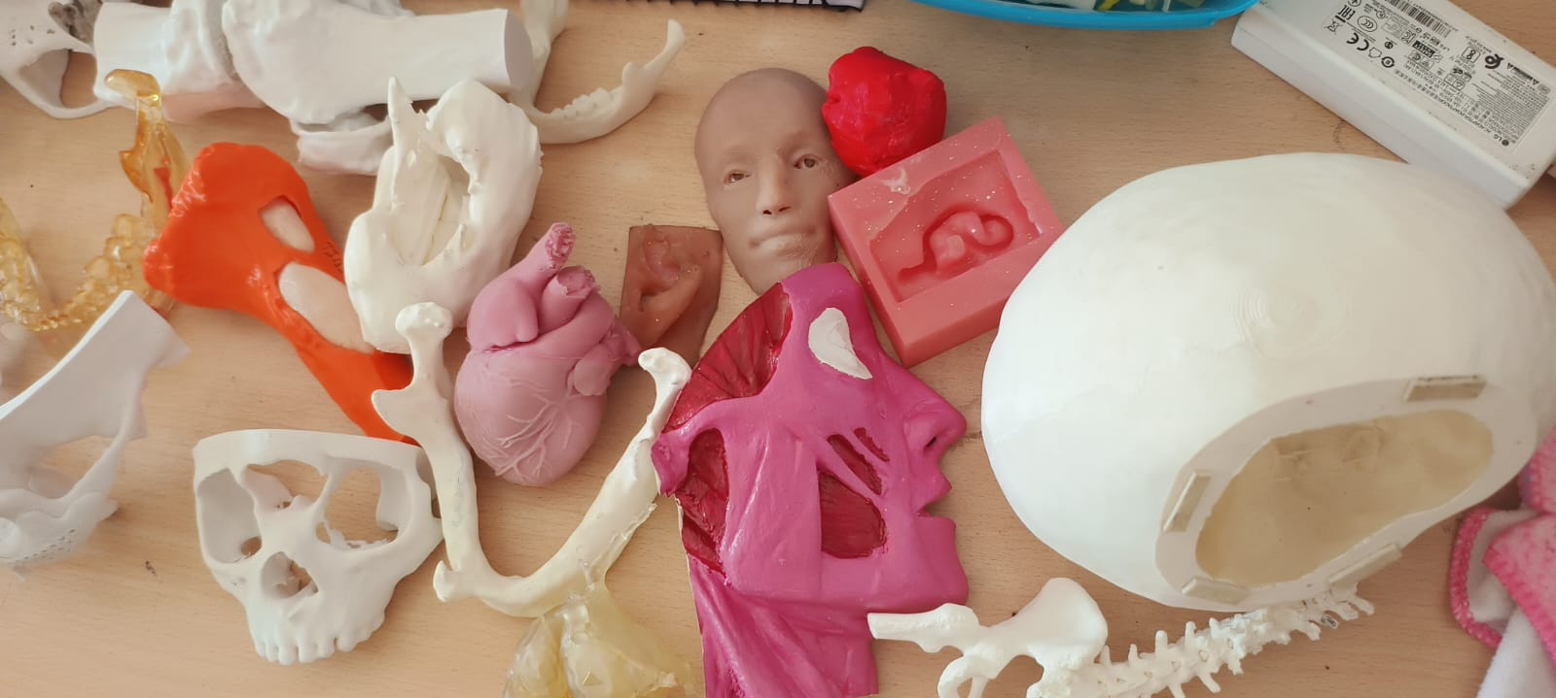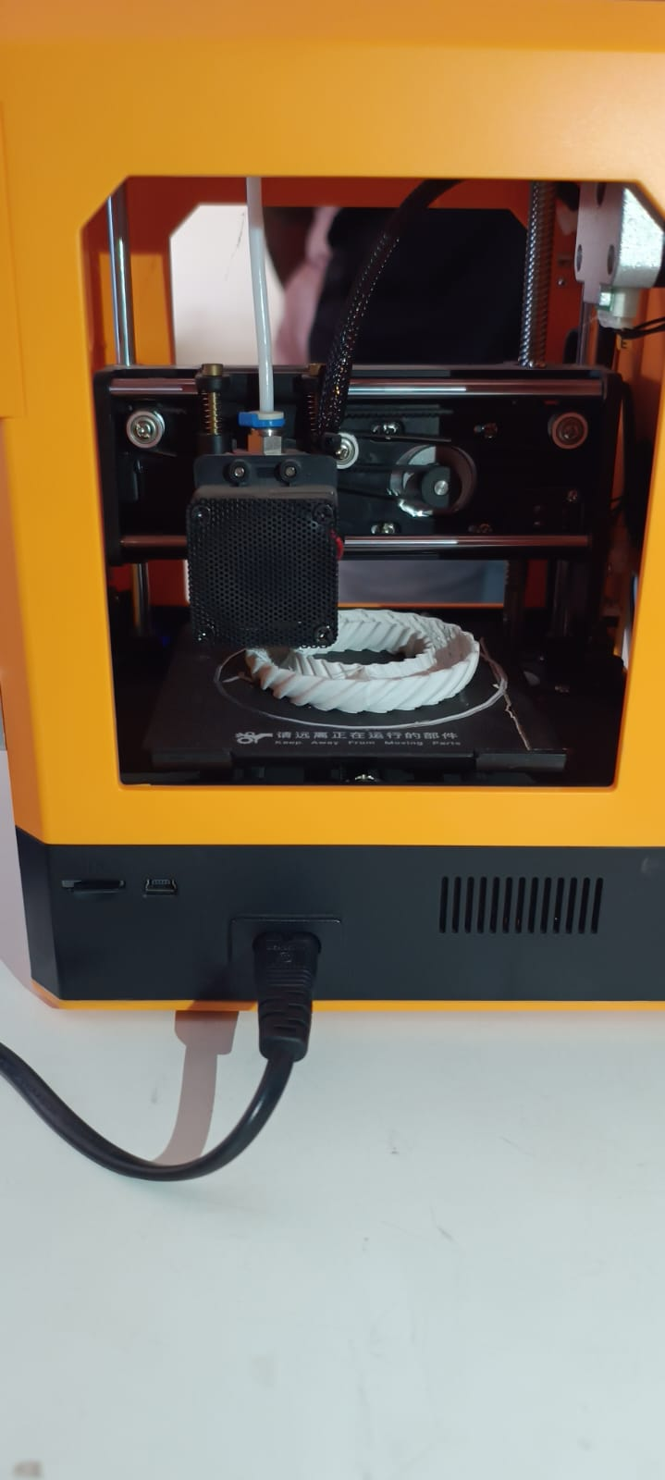

Above are the images of 3D printer and few prototypes of anatomical models.
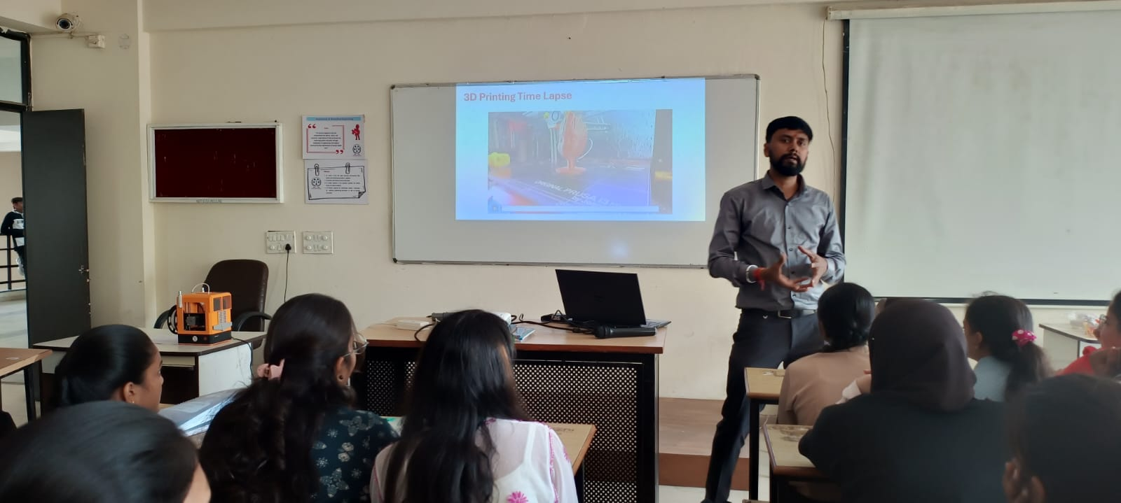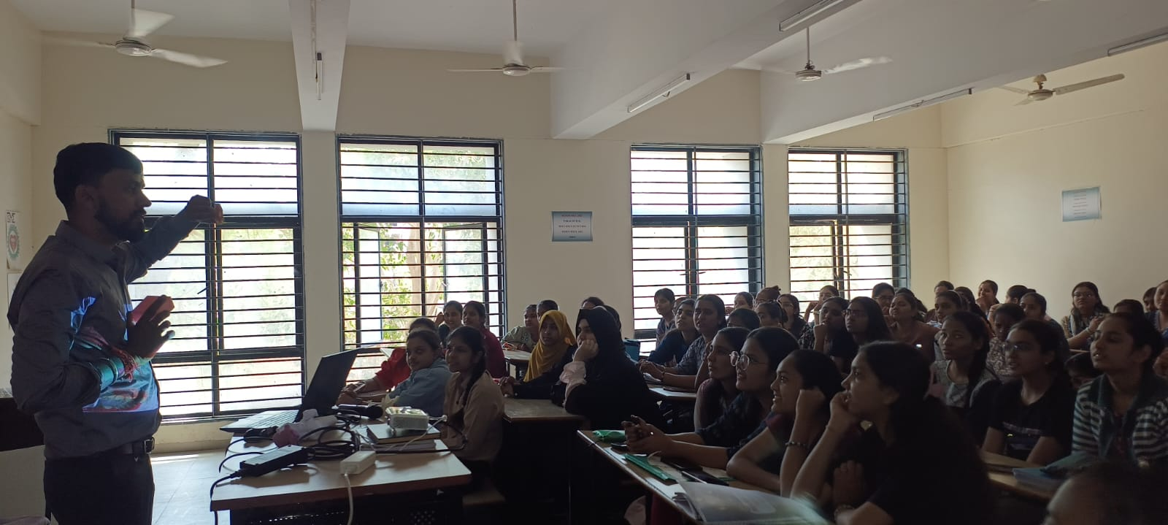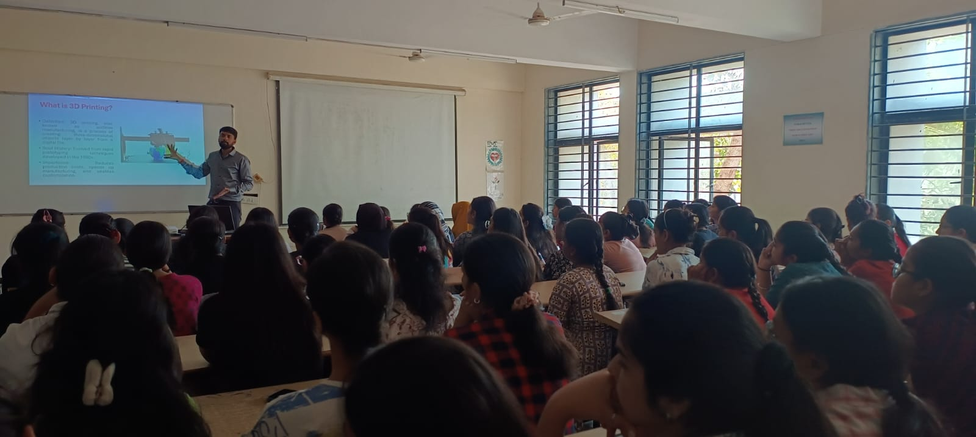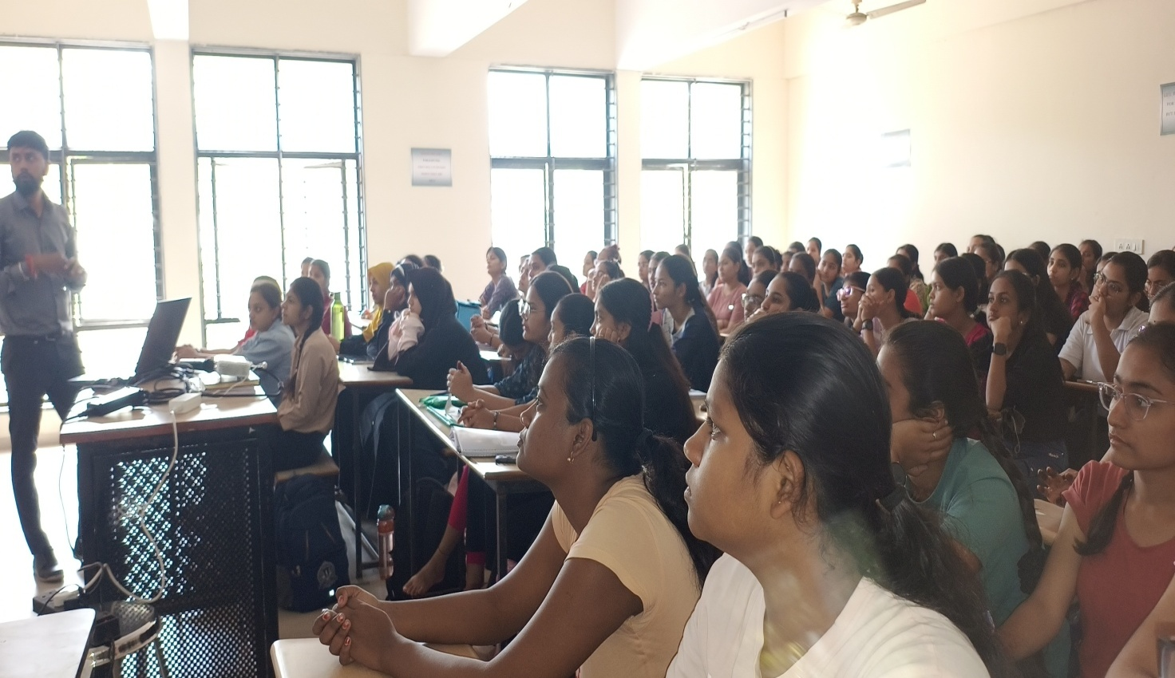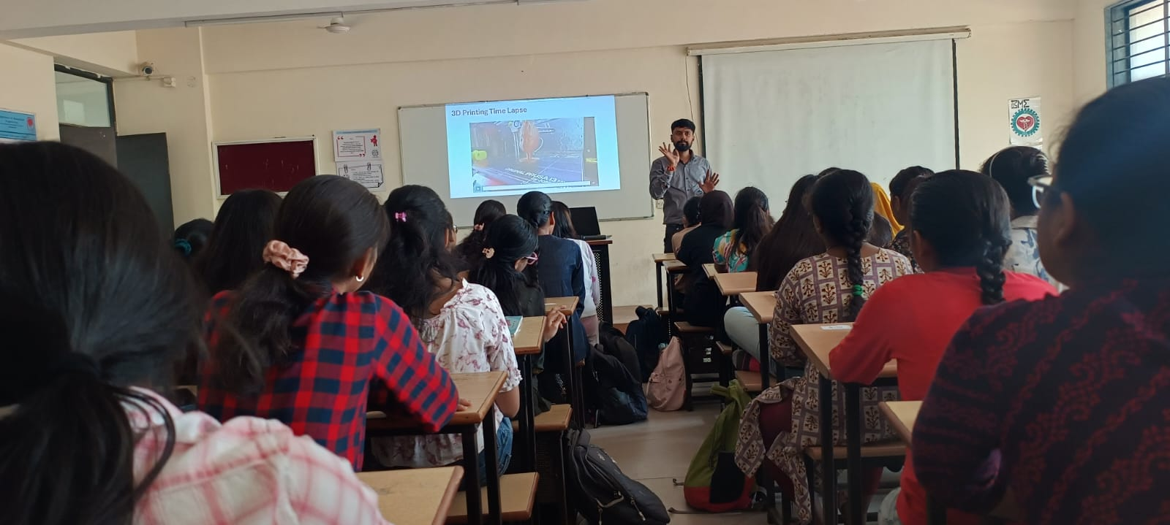
Head of the Department

