Report on Expert Session

Particulars | Details
Name of Institute | Government Polytechnic for Girls, Ahmedabad
Name of Event | From circuits to code: Basics of Arduino and Arduino programming
Types of Event | Hands on training session
Organizing Institute | Department of Biomedical Engg.,Government Polytechnic for Girls, Ahmedabad
Start date of Event | 27/02/2026
Time | 11:00 AM to 03:00 PM
Name of Expert | Ms. Ami Gandhi (Assistant Professor, Electronics & communications department, L.D. College of Engg., Ahmedabad)
Faculty Coordinator | Ms. Jimisha H. Suthar  Mr. Rakesh D Motka
Nature of Participation in Event | Students only
Number of Participants in Event | 51
Venue | Department of Biomedical Engg.,Government Polytechnic for Girls, Ahmedabad
Mode of advertisement of event | Notice Board, Students Whatsapp Group
Description of Events | The Department of Biomedical Engineering at Government Polytechnic for Girls, Ahmedabad organized an expert session titled “From Circuits to Code: Arduino Hands-on Training” on 27th February 2026 (Friday) at 11:00 AM.  The session was delivered by Ami Gandhi, Assistant Professor from the Electronics and Communication Department at L.D. College of Engineering. The objective of the session was to introduce students to Arduino hardware and programming and provide practical exposure to its applications.  During the session, the expert explained the basics of the Arduino platform and demonstrated the use of an Arduino board along with various circuit components. Students were also given hands-on training to write and execute simple Arduino programs and understand hardware interfacing.  A total of 51 students from Semester 4 and Semester 6 participated in the session. The training proved highly beneficial, particularly for Semester 6 students who are currently working on Arduino-based projects as part of their curriculum. It also provided valuable preliminary exposure for Semester 4 students who will undertake similar projects in the upcoming semester. Overall, the session was interactive and helped students gain practical understanding of Arduino applications in biomedical engineering.
Learning Outcomes: | After attending the session, students were able to:  - Understand the basic architecture and working of the Arduino platform.  - Develop and execute simple Arduino programs using the Arduino IDE.  - Gain practical exposure to interfacing basic electronic components and sensors with Arduino for biomedical applications.

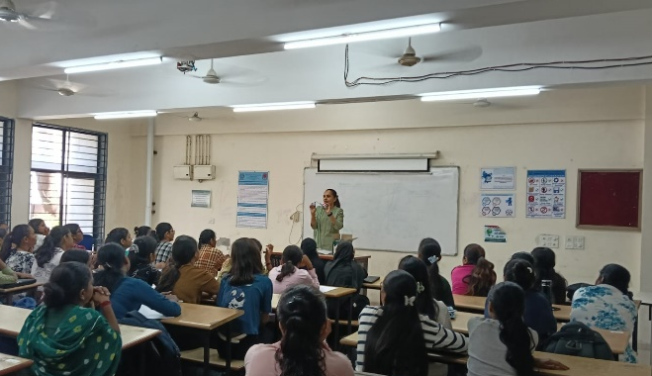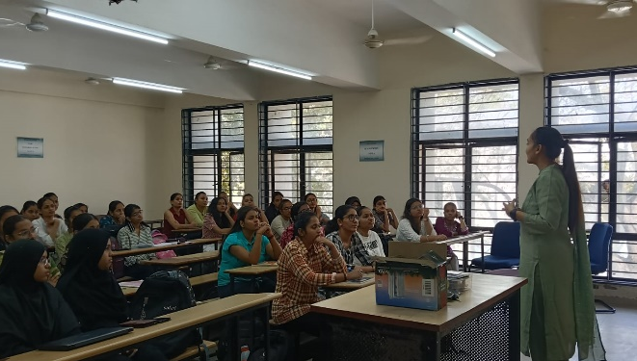
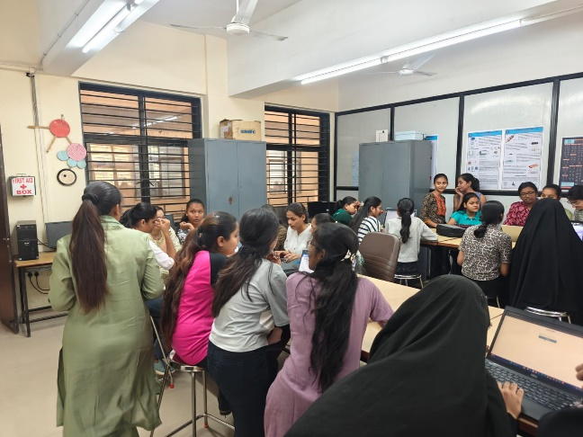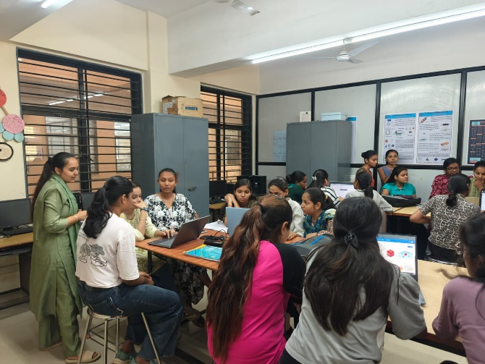

HOD
Department of Biomedical Engg.

