Particulars | Details
Name of Institute | Government Polytechnic for Girls, Ahmedabad
Name of Event | 3D Printing for Life-Applications of Additive Manufacturing in Healthcare
Types of Event | Workshop
Organizing Institute | NAMC-W (National Additive Manufacturing Center- West) Ganpat University, Kherva, Mehsana
Start date of Event | 21/02/2026
Time | 09:30 AM to 03:30 PM
Name of Expert | Prof. Achyut Trivedi (Chairperson, CoE, Additive Manufacturing, NAMC-W) , Prof H.A. Patel (Head of Department, Biomedical Engineering, UVPCE)
Faculty Coordinator | Ms. Jimisha H. Suthar  Mr. Rakesh D Motka
Nature of Participation in Event | Students only
Number of Participants in Event | 42
Venue | NAMC-W (National Additive Manufacturing Center- West) Ganpat University, Kherva, Mehsana
Mode of advertisement of event | University website, Notice Board, Students Whatsapp Group
Description of Events | NAMC-W is a project initiated by Ministry of Information & Technology - Government of India, Ganpat University, and Additive Manufacturing Foundation and in association with industrial Partners.  A total of 42 students and 2 faculty members from the Biomedical Engineering Department participated in the one-day workshop “3D Printing for Life: Application of Additive Manufacturing in Healthcare” organized by U.V. Patel College of Engineering, Ganpat University in association with NAMCW.  Transportation (bus pickup and drop from the college), along with breakfast and lunch, was arranged by the organizers. All participating students were appreciated and awarded certificates upon successful completion of the workshop.
Learning Outcomes: | Understanding of Industrial 3D Printing Systems  Students gained practical exposure to different industrial additive manufacturing technologies, including high-end systems such as Stratasys printers, and understood their working principles, materials used, and healthcare applications.  Knowledge of Post-Processing Techniques  Students observed integrated post-processing equipment associated with industrial 3D printers and understood the importance of support removal, curing, surface finishing, and sterilization considerations in medical device fabrication.  Application of Additive Manufacturing in Healthcare  Students were able to correlate 3D printing technologies with biomedical applications such as patient-specific implants, prosthetics, anatomical models, and surgical guides, and critically evaluate their advantages over conventional manufacturing methods.

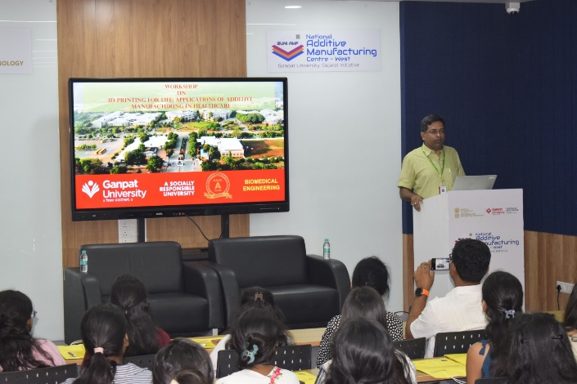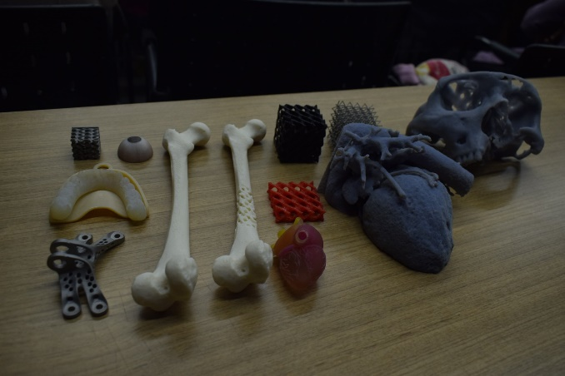
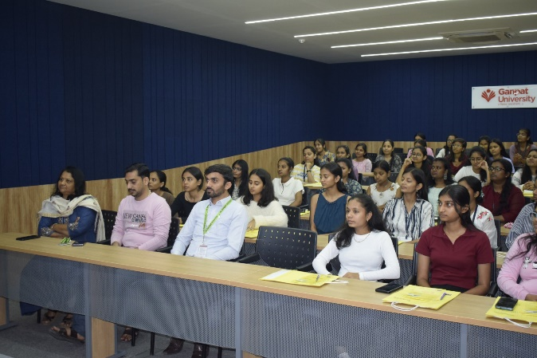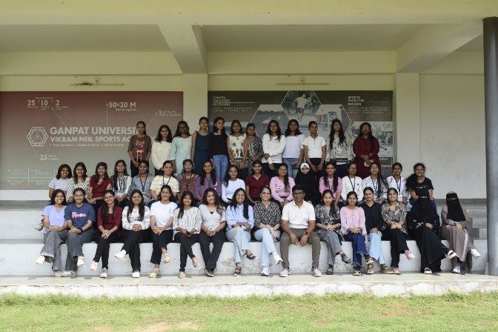

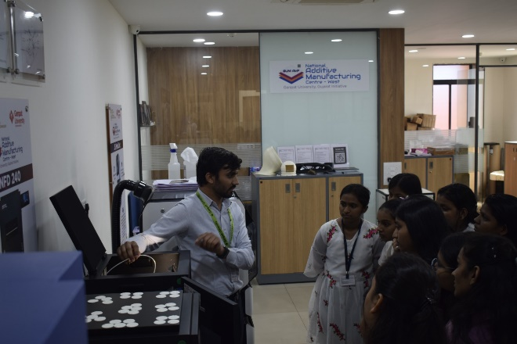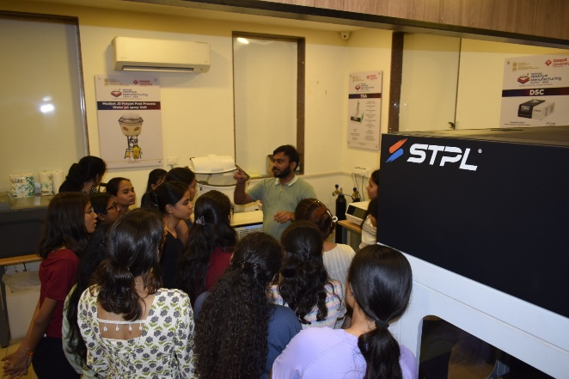
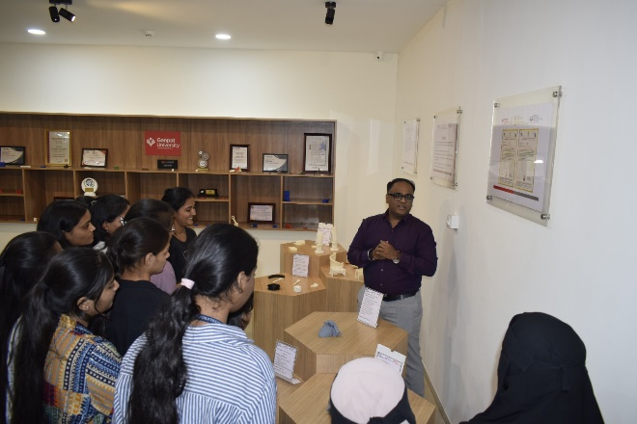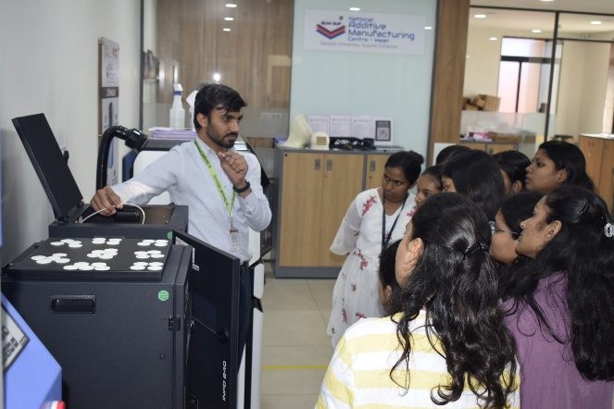

HOD
Department of Biomedical Engg.

