|  |  |  |
| --- | --- | --- |
| institute gpg logo black and white.jpg | **GOVERNMENT POLYTECHNIC FOR GIRLS, AHMEDABAD**  **CIVIL ENGINEERING DEPARTMENT** | department logo gpg civil.jpg |

**Award & Achievement of Student**

|  |  |  |  |  |  |
| --- | --- | --- | --- | --- | --- |
| **FOLLOWING STUDENTS WERE AWARDED BY T**he Gujarat Institute Of Civil Engineers & Architects WITH MEDALE & CERTIFICATE. | | | | | |
| SR NO | ENROLLMENT NO | NAME | ORGANIZATION | MEDAL/ CERTIFICATE | YEAR |
| 1 | 146140306027 | GOTAR SNEHA R. | GICEA | MEDAL & CERTIFICAT | 2017 |
| 2 | 156140306019 | ZEEL PRADIP DAVE | GICEA | MEDAL & CERTIFICAT | 2018 |
|
| 3 | 166140306067 | PARMAR VIBHASHREE KIRTIKUMAR | GICEA | MEDAL & CERTIFICAT | 2019 |
| 4 | 176140306108 | SHAH JEEL PANKIT KUMAR | GICEA | MEDAL & CERTIFICAT | 2020 |
| 5 | 186140306011 | CHAUDHARI BHAVNABEN BALVANTBHAI | GICEA | MEDAL & CERTIFICAT | 2021 |
| 6 | 196140306089 | PRAJAPATI ANJALI | GICEA | MEDAL & CERTIFICAT | 2022 |
| 7 | 206140306016 | MANUSHREE KETAN TRIVEDI | GICEA | MEDAL & CERTIFICAT | 2023 |
| 8 | 216140306009 | MANAT TINKALBEN KHEMRAJBHAI | GICEA | MEDAL & CERTIFICAT | 2024 |

|  |  |
| --- | --- |
|  |  |
|  |

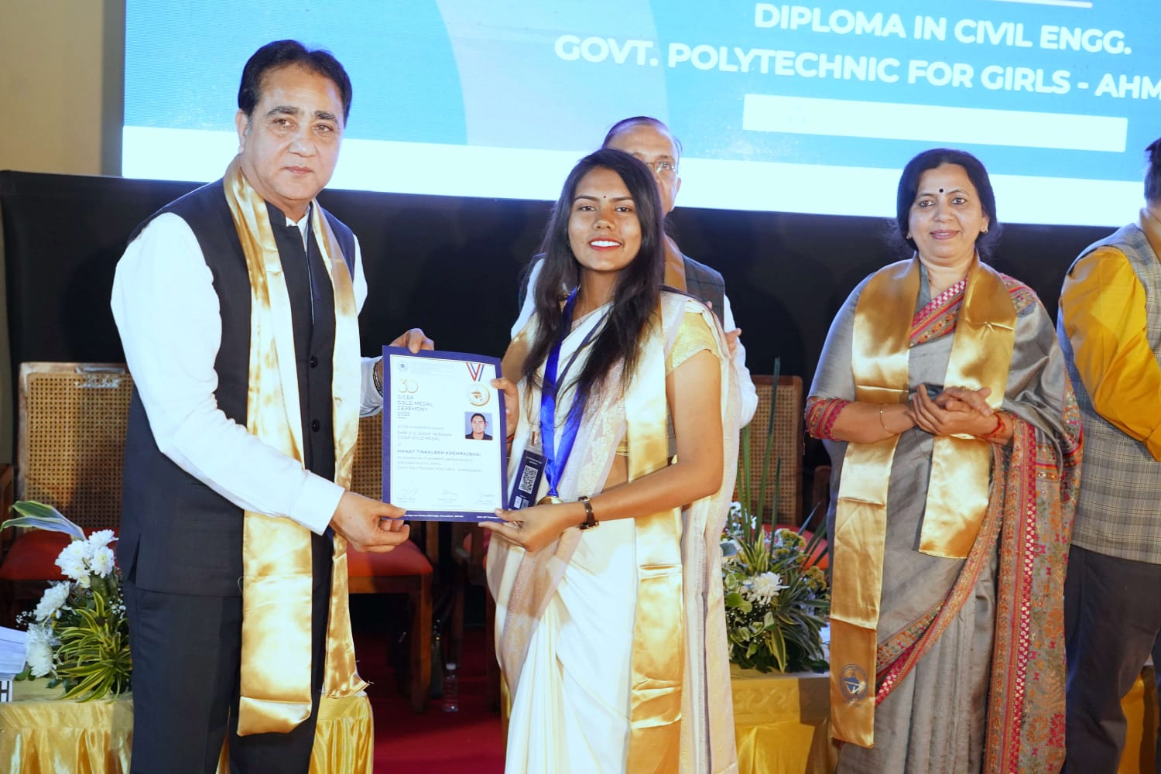**ACADAMIC ACHIVMENT WITH SECURING TOP THREE POSITION IN DEPARTMENT & APPRECIATION BY CIVIL DEPARTMENT**

|  |  |  |  |  |  |
| --- | --- | --- | --- | --- | --- |
| **GOVERNMENT POLYTECHNIC FOR GIRLS, AHMEDABAD** | | | | | |
| **CIVIL ENGINEERING DEPARTMENT** | | | | | |
| **LIST OF TOP 3 STUDENTS** | | | | | |
| TERM 241 | | | | | |
| **sem** | **MAP_NUMBER** | **name** | **SPI** | **CPI** | **CGPA** |
| 3 | 236140306013 | DHARAVA HIRAL RAJESHBHAI | 9.1 | 9.05 | 9.1 |
| 3 | 236140306009 | CHINCHGHRE RIDDHI ANKUSHBHAI | 8.85 | 8.24 | 8.85 |
| 3 | 236140306012 | DHANAK NUPUR DHIRAJBHAI | 8.45 | 8.05 | 8.45 |
| 3 | 236140306043 | SHAH HEER JIGNESHBHAI | 8.45 | 8.32 | 8.45 |
| **sem** | **MAP_NUMBER** | **name** | **SPI** | **CPI** | **CGPA** |
| 5 | 226140306007 | BURMAWALA ZAINAB A.RAUF | 8.95 | 8.88 | 8.85 |
| 5 | 226140306015 | KHAMBHOLJA JIYA HEMALKUMAR | 9.05 | 8.35 | 8.67 |
| 5 | 226140306018 | MEVADA DIVYA DILIPKUMAR | 8.5 | 8.24 | 8.6 |
| **TERM 232** | | | | | |
| **sem** | **MAP_NUMBER** | **name** | **SPI** | **CPI** | |
| **2** | 236140306013 | DHARAVA HIRAL RAJESHBHAI | 9.14 | 9.02 | |
| **2** | 236140306051 | VAKIL DWIJA DHAVAL | 8.59 | 8.62 | |
| **2** | 236140306043 | SHAH HEER JIGNESHBHAI | 8.23 | 8.26 | |
| **sem** | **MAP_NUMBER** | **name** | **SPI** | **CPI** | **CGPA** |
| **4** | 226140306007 | BURMAWALA ZAINAB A.RAUF | 8.8 | 8.87 | 8.8 |
| **4** | 226140306018 | MEVADA DIVYA DILIPKUMAR | 8.85 | 8.17 | 8.65 |
| **4** | 226140306015 | KHAMBHOLJA JIYA HEMALKUMAR | 8.35 | 8.18 | 8.48 |
| **sem** | **MAP_NUMBER** | **name** | **SPI** | **CPI** | **CGPA** |
| **6** | 216140306009 | MANAT TINKALBEN KHEMRAJBHAI | 8.68 | 8.15 | 8.95 |
| **6** | 216140306003 | PRAJAPATI KAVYA DIPAKBHAI | 8.63 | 8.55 | 8.8 |
| **6** | 216140306028 | GAJJAR URJA VIJAYKUMAR | 8.53 | 8.57 | 8.71 |
| **TERM 231** | | | | | |
| **sem** | **MAP_NUMBER** | **name** | **SPI** | **CPI** | |
| 1 | 236140306013 | DHARAVA HIRAL RAJESHBHAI | 8.9 | 8.9 | |
| 1 | 236140306051 | VAKIL DWIJA DHAVAL | 8.65 | 8.65 | |
| 1 | 236140306043 | SHAH HEER JIGNESHBHAI | 8.3 | 8.3 | |
| **sem** | **MAP_NUMBER** | **name** | **SPI** | **CPI** | **CGPA** |
| 3 | 226140306007 | BURMAWALA ZAINAB A.RAUF | 8.8 | 8.89 | 8.8 |
| 3 | 226140306015 | KHAMBHOLJA JIYA HEMALKUMAR | 8.6 | 8.13 | 8.6 |
| 3 | 226140306018 | MEVADA DIVYA DILIPKUMAR | 8.45 | 7.95 | 8.45 |
| **sem** | **MAP_NUMBER** | **name** | **SPI** | **CPI** | **CGPA** |
| 5 | 216140306003 | PRAJAPATI KAVYA DIPAKBHAI | 9.65 | 8.54 | 8.85 |
| 5 | 216140306028 | GAJJAR URJA VIJAYKUMAR | 9.3 | 8.58 | 8.77 |
| 5 | 216140306008 | Patel Soni Tulsibhai | 8.4 | 8.11 | 8.68 |
| **TERM 222** | | | | | |
| **sem** | **MAP_NUMBER** | **name** | **SPI** | **CPI** | |
| 2 | 226140306007 | BURMAWALA ZAINAB A.RAUF | 8.68 | 8.93 | |
| 2 | 226140306006 | BRAHMBHATT VISHWA SHAILESHKUMAR | 7.14 | 7.74 | |
| 2 | 226140306018 | MEVADA DIVYA DILIPKUMAR | 7.77 | 7.71 | |
|  |  |  |  |  |  |
| **sem** | **MAP_NUMBER** | **name** | **SPI** | **CPI** | **CGPA** |
| 4 | 216140306008 | Patel Soni Tulsibhai | 9.15 | 8.04 | 8.83 |
| 4 | 216140306027 | THESIYA DEVANSHI JITESHBHAI | 8.6 | 7.89 | 8.6 |
| 4 | 216140306028 | GAJJAR URJA VIJAYKUMAR | 8.7 | 8.4 | 8.5 |
|  |  |  |  |  |  |
| **sem** | **EnrollmentNumber** | **Name** | **CPI** | **CGPA** | |
| 6 | 206140306016 | MANUSHREE KETAN TRIVEDI | 9.75 | 9.72 | |
| 6 | 206140306008 | MEGHNATHI RADHIKABEN PREMGAR | 9.54 | 9.56 | |
| 6 | 206140306009 | SIMRAN KAKA | 8.93 | 8.66 | |
| **TERM 221** | | | | | |
| **sem** | **MAP_NUMBER** | **name** | **SPI** | **CPI** | |
| 1 | 226140306007 | BURMAWALA ZAINAB A.RAUF | 9.2 | 9.2 | |
| 1 | 226140306006 | BRAHMBHATT VISHWA SHAILESHKUMAR | 8.4 | 8.4 | |
| 1 | 226140306018 | MEVADA DIVYA DILIPKUMAR | 7.65 | 7.65 | |
| **sem** | **MAP_NUMBER** | **name** | **SPI** | **CPI** | **CGPA** |
| 3 | 216140306009 | MANAT TINKALBEN KHEMRAJBHAI | 8.7 | 6.92 | 8.7 |
| 3 | 216140306027 | THESIYA DEVANSHI JITESHBHAI | 8.6 | 7.66 | 8.6 |
| 3 | 216140306008 | Patel Soni Tulsibhai | 8.5 | 7.68 | 8.5 |
| **sem** | **MAP_NUMBER** | **name** | **SPI** | **CPI** | **CGPA** |
| 5 | 206140306016 | Manushree Ketan Trivedi | 9.64 | 9.73 | 9.67 |
| 5 | 206140306008 | MEGHNATHI RADHIKABEN PREMGAR | 9.27 | 9.44 | 9.41 |
| 5 | 206140306009 | SIMRAN KAKA | 8.48 | 8.87 | 8.48 |



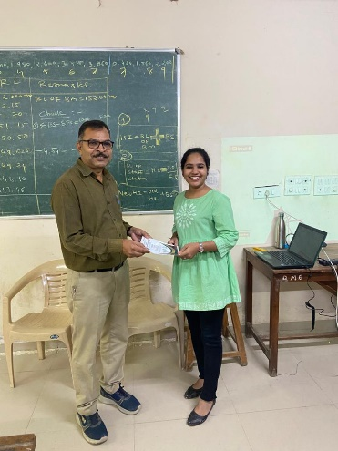 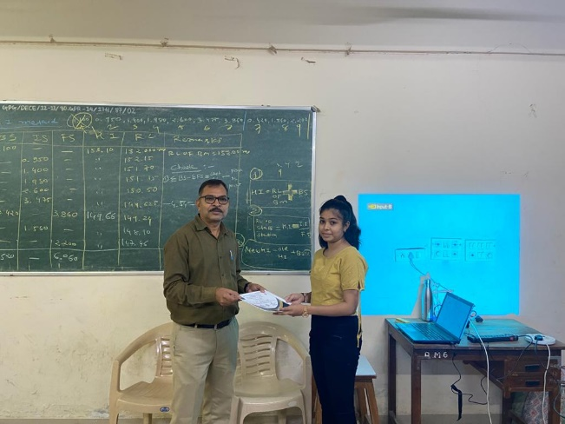

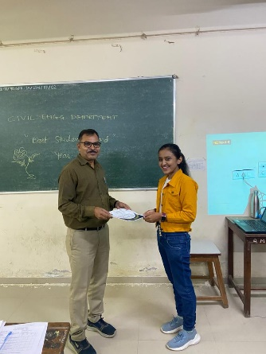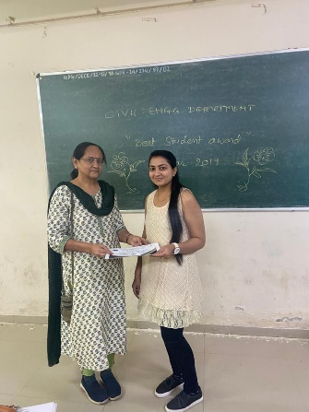

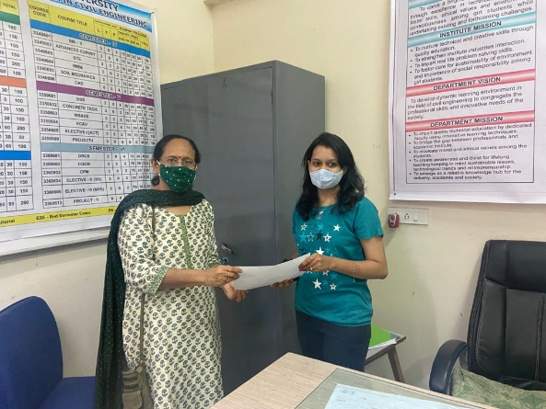











**Award & Achievement of Faculty**

**Book Publication**

|  |  |  |  |
| --- | --- | --- | --- |
| **SR NO** | **Name of faculty** | **Name of publication** | **ISBN Number** |
| 1. | Mr. K. M. Vora | Gujarat Technical Publishers (Structure) | 978-93-85016-93-6 |
| 2. | Mr. K. M. Vora | Mahi Publication (Concrete Construction) | 978-93-89339-55-0 |
|  |  |  |  |

**Gujarat Technical Publishers (Structure):** This book is for benefit of architecture as well as civil engineering diploma students. This book is designed as per GTU curriculum.

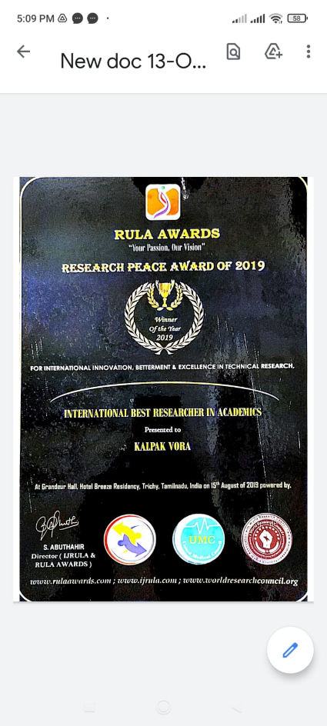**Mahi Publication (Concrete Construction):** This book is for benefit of civil engineering diploma students. This book is designed as per GTU curriculum. This book is very much useful for understanding all concepts of concrete structures.

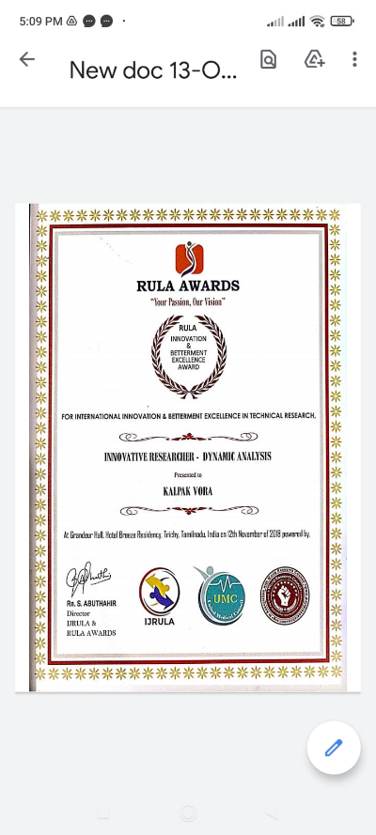

**Paper Published**

|  |  |  |  |  |  |
| --- | --- | --- | --- | --- | --- |
| **SR NO** | **Name of faculty** | **Name of Research Paper** | **ISBN Number** | **Name of Jouranal** | **Year** |
| 1. | DR. D.H.DALAL | An Experimental Study to locate leakage in the water distribution network using Real time wireless sensors and Machine learning algoridhem | 1133-1142 | Indian journal of science and technology | 2022 |
| 2. | DR. D.H.DALAL | A review on comparison of different water leak detection techniques suitable for Indian scenario | 0973-4929 | Current world enviornment | 2022 |

**Paper Presented**

|  |  |  |  |  |
| --- | --- | --- | --- | --- |
| **SR NO** | **Name of faculty** | **Name of Research Paper** | **Name of Conference** | **Year** |
| 1. | DR. D.H.DALAL | Contribution by various authors to detect leakage from water distribution network | 1st International Conference on "Advances in Water Treatment and Management | 25th- 26th March, 2022 |
| 2. | DR. D.H.DALAL | Leakage detection in water distribution network using WSN in smart cities | 1st International Conference on "Advances in Water Treatment and Management | 25th- 26th March, 2022 |

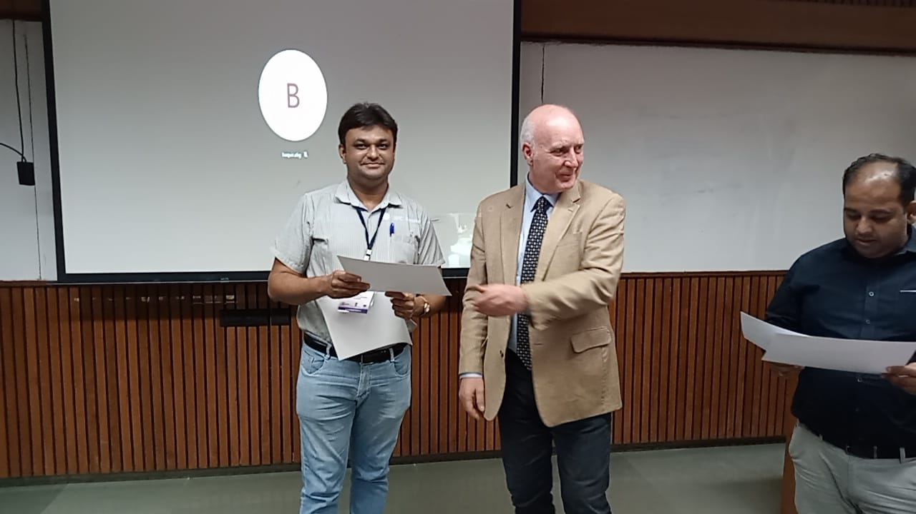

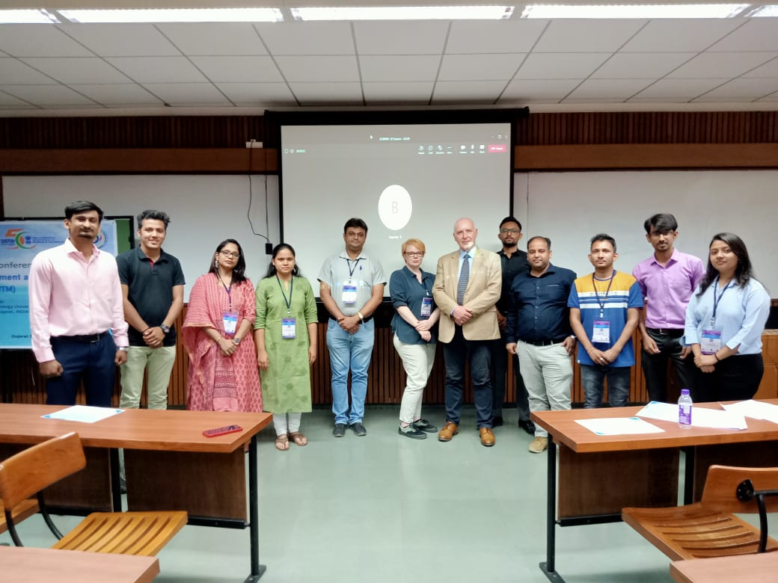

**Achievements**

|  |  |  |  |
| --- | --- | --- | --- |
| **SR NO** | **Name of faculty** | **Name of Award** | **Award given by** |
| **1.** | **Dr. D.H.Dalal** | **Achieve Ph.D Degree in Civil Engineering from GTU in June 2023** | **Honourable Governor of Gujarat Devrat Acharya Ji** |
| 2. | Mr. K. M. Vora | Innovation and betterment excellence award (Innovative Researcher-Dynamic Analysis) | RULA – (NOVEMBER 2018) |
| 3. | Mr. K. M. Vora | Research peace award of 2019 (International Best Researcher in Academics) | RULA – (AUGUST 2019) |

**(RULA: Research Under Literal Access)**

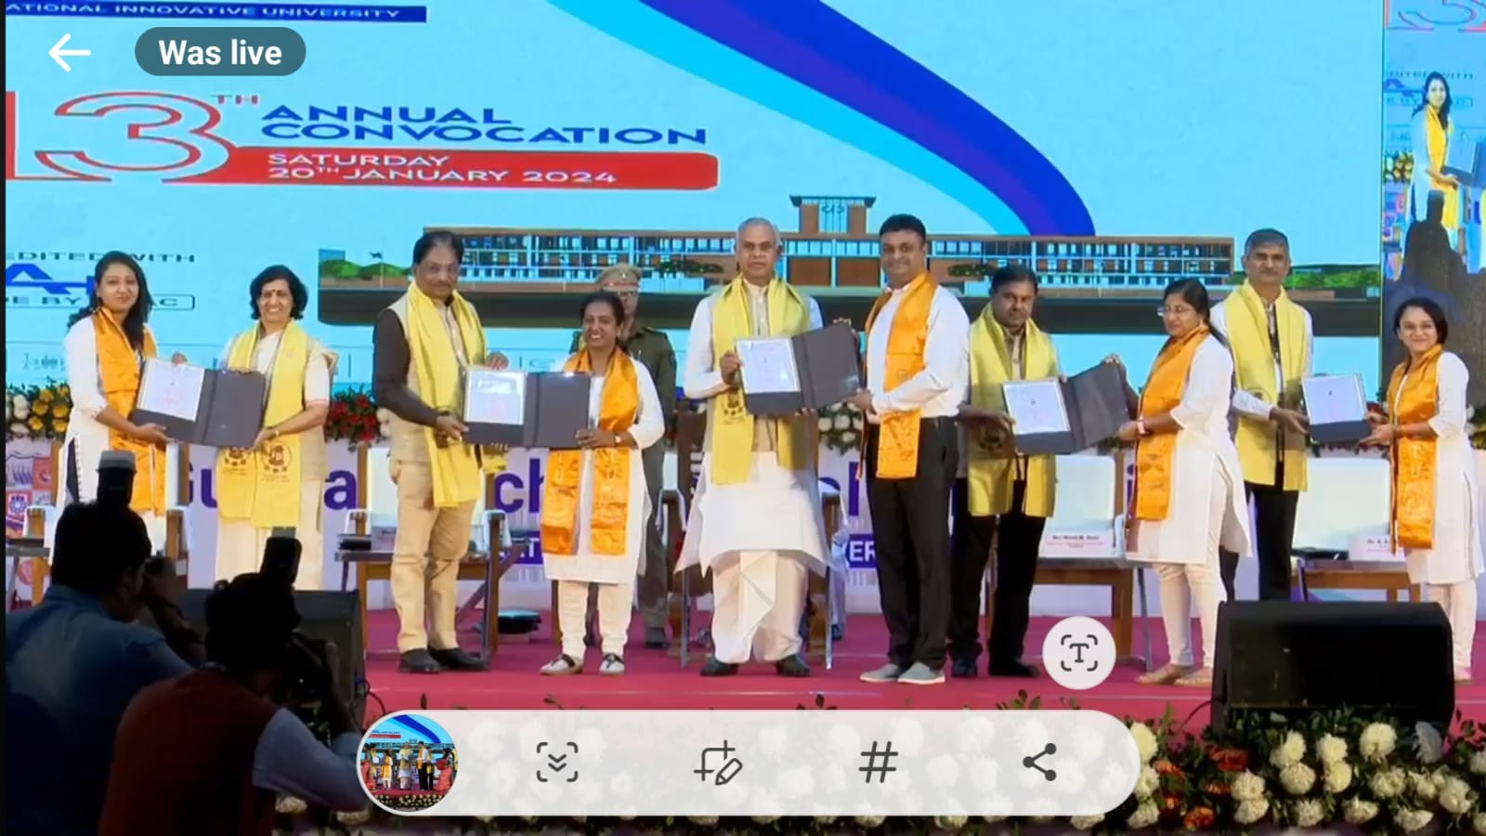

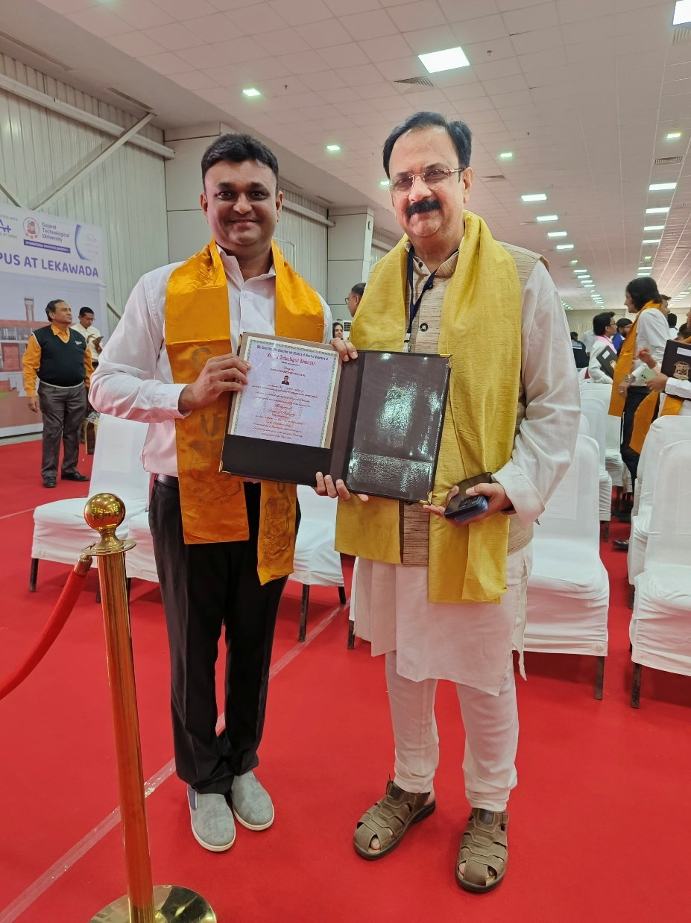

**Expert lecture   
Delivered**

|  |  |  |  |  |
| --- | --- | --- | --- | --- |
| **SR NO** | **Name of faculty** | **Name of Topic** | **Organizing Institute** | **Date** |
| **1.** | **Dr. D.H.Dalal** | **New trends and innovations in Civil Engineering** | **STTP organized by Darshan University** | **06/02/2024** |

